BUGS IN THE BEAM
A Manual for Cytometry in Microbiology

Handouts for the Tutorial on Microbial Flow Cytometry

See also
Special issue free full-text issue of the Journal of Microbiological Methods

Volume 42/1, September 2000, Microbial Analysis at the Single Cell Level,
guest-edited by: L. Alberghina, D. Porro, H. Shapiro, F. Srienc, H. Steen.
See
http://www.elsevier.com/homepage/sah/mimet/speciss/1378.pdf

and
http://intl.highwire.org/
to receive freely available articles (published normally more than 6 month to a year ago)

The Program:
The aim of the tutorial is to give flow cytometry users the confidence and the technical background to tackle the measurement of bacteria. To achieve that there will be a theoretical part and presentations of practical applications, accompanied by protocols and reference literature

Gerhard Nebe-von Caron
Swiss Precision Diagnostic
Priory Bus. Park,
Bedford
Bedfordshire
GB - MK44 3UP
Tel.: +44-(0)1234-835474
FAX: +44-(0)1234-835002
E.mail: gerne@bigfoot.com

1 Background Information 3
1.1 Cytometry, bulk and single cell measurements 3
1.2 Flow cytometry and single cell sorting 4
1.3 Historical background 6
2 Technical background 9
2.1 Setting the environment : 9
2.1.1 Requirement on labware and reagents. 9
2.1.2 Preparation and handling of dye solutions 9
2.1.3 Sample Handling 10
2.2 Setting up the instrument : Calibration standards, Discriminator settings 10
2.3 Signal processing: Bacterial discrimination, back-gating 11
2.4 Light Scatter measurements : Opportunities and limitations 12
2.5 Sorting bacteria : Instrument preparations and sorting 15
3 Functional and differential labelling of bacteria 17
3.1 Bacterial enumeration: Sample handling, disaggregation and counting methods. 17
3.1.1 Counting methods 17
3.1.2 Sample disaggregation 18
3.2 The viability concept 20
3.2.1 Reproductive growth 21
3.2.2 Metabolic activity measurements 22
3.2.3 Membrane integrity 28
3.3 Assessment of stress and injury by three colour multiparametric analysis 32
3.3.1 Changes in membrane functionality in starvation and germination 32
3.3.2 The culture shock; recovery of injured Salmonella typhimurium 36
3.4 Bacterial differentiation: Antibody staining of ‘environmental’ samples. 40
3.4.1 Classical differentiation methods 40
3.4.2 Differentiation by nucleic acid probes 40
3.4.3 Identification by immunological methods 40
Bibliography 44
4 Microbial Flow Cytometry in Biotechnology (Susann Müller) 50
4.1 Yeasts 50
4.1.1 Analysis of 3ß-hydroxysterols 50
4.1.2 Analysis of DNA 51
4.1.3 Analysis of neutral lipids with nile red 51
4.2 Bacteria 51
4.2.1 Methylotrophic gram-negative bacteria 51
4.2.2 Determination of the membrane potential in gram-negative strains 53
4.2.3 Application of strain specific rRNA probesto gram-negative bacteria 53

Background Information
The direct microscopical observation of “animalcules” by Leeuwenhoek in 1674 as described in his letters to the British Royal Society has been one of the key events of science of the last few centuries. It facilitated the understanding of the single cell nature of bacteria. The fact that one of these small organisms can give rise to an entire culture or colony has given microbiologists a single cell analysis system of outstanding detection sensitivity without the need for high tech equipment. The high amplification factor from 1 cell to 10¹⁰ cells and more, and the simple visual detection gave rise to a variety of microbiological tests based on cell growth.
The improvement in microscopic analysis of stressed and injured cells or the observations in extreme environmental conditions, in particular in connection with fluorescent probes, have highlighted the discrepancies between bacterial existence and their replication. The experience of replication in the form of raising children can give a ‘macroscopic’ insight in the stress and lifestyle changes caused by such process. To avoid similar distortions caused by post sampling growth, it appears that observations into natural microbial populations have to be based on direct optical detection methods on the single cell level.

Cytometry, bulk and single cell measurements
Because of the importance of microbiology to human health, methods have been developed to enumerate bacteria to identify them and to look at the impact of physical, chemical of biological interventions. Bulk measurements like changes in turbidity, conductivity or gas pressure of liquid media (Figure 1) have become popular for bacterial detection because of their ease of handling, their detection speed. Selective growth media can allow some degree of bacterial differentiation, but detailed differentiation is still achieved by cell isolation followed by either biochemical, immunological or genetic characterisation. Whilst immunological and genetic differentiation can also be applied directly to certain samples, preenrichment steps are usually applied to generate sufficient signal.

Figure 1: Cytometry as bulk or single cell measurements
Bulk measurements are usually easy to perform and less expensive. In most cases cell growth is required to generate enough signal. Direct single cell measurements on the other hand tend to be more complex. They do not require post sampling growth and can reflect the true heterogeneity of microbial populations.

The cornerstone of microbiology has been single cell analysis. Colonies derived from single cells have been examined by the plating techniques developed by Koch more than a century ago. The strength of this technique, the high amplification factor of 10⁹⁻¹² is also its weakness, the dependence on growth. In the times of Pasteur and Koch as well as nowadays, this growth limitation can only be overcome by direct single cell measurements like image or flow cytometric methods, which also allow assessment of the true amount of sample heterogeneity. The power of the combination of image analysis and microscopy was already appreciated by Koch, who took pictures of his microscopic images. The spatial resolution of the microscope not only allows the characterisation of cell morphology, but also the position of bacteria within a sample matrix. This can give information about its development of biofilms or potential symbiotic interactions. Unfortunately the high amount of data processing in computerised image analysis limits the sample throughput and the analysis of high cell numbers, which are better achieved by the measurement of cell suspensions by flow cytometry (FCM). Spatial resolution of FCM is more macroscopic, related to the site of sampling. Only recently, hybrids between both technologies have become available in the form of laser scanning cytometers and, perhaps in the long run, the restriction of image analysis to data processing of critical data only may lead us back to the microscopical beginning.

Flow cytometry and single cell sorting
In a flow cytometer cells, or other particulate matter, flow through a zone of investigation where parameters of interest are measured. The history of bacterial flow cytometry probably starts with the work of Tyndall in the mid 19th century. He detected the absence of particles in the air of his dust free box by means of light scattering in a light beam as illustrated in microbiology text books (e.g. Pelczar, Jr. et al. 1993). And nearly 200 years after the onset of cytometry by Leeuwenhoek, it was Robert Koch’s manual cell sorting which led to the isolation of Bacillus anthracis, proving the link between a disease and a certain bacterium.
In modern flow cytometers the measurement is taken electronically. The classic example of FCM is the Coulter Counter, where cells are suspended in a particle free solution and a fixed volume is passed through a narrow orifice. Depending on their size, the particles change the electric current running across the orifice, generating signals which give rise to accurate enumeration and particle sizing. In the context of this study flow cytometry is restricted to instruments based on optical measurements. The major elements of such a modern multi parameter flow cytometer are shown in Figure 2. Typically, light scatter and fluorescence signals are measured to provide a variety of information on, for example, surface-structure, membrane permeability, pH, or DNA/RNA content. The fluidic system is designed to guide the cells in single file through the centre of a focused laser beam (hydrodynamic focusing). The amount of light scattered or emitted by each particle is measured, digitalized and fed into a computer. There the different optical signals are correlated and groups or clusters of cells are identified and statistically analysed as shown in Figure 3.
Certain instruments allow the user not only to analyse these cell populations but also sort them for preparative purposes. From all the sorting principles (Lindmo et al. 1990) the droplet-based sorters have become the most widespread systems. In those sorters the flow chamber vibrates vertically at a high frequency and the out-coming liquid stream is disrupted into small uniform droplets. At a fixed time after the cell is measured it reaches the last droplet attached to the liquid stream. If the cell falls in a cluster of interest, it is then selected for sorting and the liquid stream is charged positively or negatively for the time of droplet separation. Depending on the charge, the droplet is deflected in an electric field into collection vessels for subsequent analysis.
The strength of flow cytometry lies in its capacity for single cell measurements, its acquisition speed and its numerical power. The total illumination of the particle in the laser beam allows the quantification of the fluorescence intensity per particle. By looking at multiple parameters of a thousand cells per second, groups or clusters can be identified. Screening several thousand cells also allows the detection of low frequency events with a statistical significance. Correct total enumeration of aerobic, anaerobic and facultative anaerobic bacteria in mixed populations becomes possible, as the method does not depend on post sampling growth.
The most detailed descriptions of flow cytometric systems, including how to build your own, can be found in “Practical Flow Cytometry” by Howard Shapiro (Shapiro, 1995). It also represents the most comprehensive source about staining techniques which can be applied. Flow Cytometry and Sorting (Anonymous1990a) also gives detailed technical background on flow cytometry and there are other extensive manuals such as “Current Protocols”, “Flow Cytometry” as part of “Methods in Cell Biology” (Anonymous1994) that cover various aspects of the technology. The handbooks of Longobardi-Givian (Longobardi-Givian, 1992), Ormerod (Anonymous1990b) and particularly the manual published by the Royal Microscopical Society (Ormerod, 1994) might serve as a more easy to read literature for beginners that focus on the essential concepts.

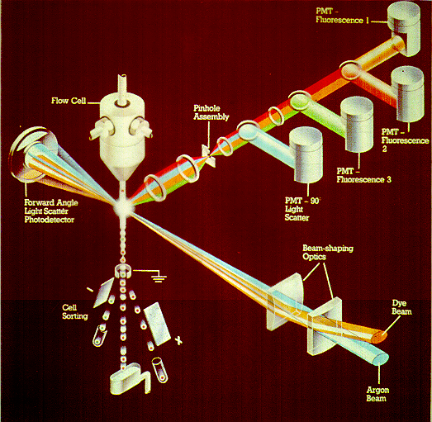
Figure 2: Detection system of a generalised “five parameter” laser based flow cytometer
A sheath flow is running through a flow cell forming a laminar liquid stream. Into this stream a particle or cell suspension is injected to be guided into a sensing zone in single file, one after the other. Whenever a cell or particle goes through the intercept with the illuminating laser beam, light is scattered. Photons of the same wavelength as the incoming light are collected axial and perpendicular to the light beam (forward angle and right angle light scatter). Fluorescent signals are also collected perpendicular to the light beam and separated onto different detectors using mirrors and filters with appropriate spectral characteristics. The photomultiplier tubes (PMT’s) convert the light intensity into electric signals that are fed into a computer. Cell sorting is achieved by vertically vibrating the flow cell at several thousand hertz to generate uniform droplets. If an event fulfils the desired scatter and fluorescent properties, the whole liquid system is charged with a high voltage when this cell has reached the point of droplet breakoff. Depending on the given charge, the droplet containing that cell can therefore be deflected in an electric field and deposited in tubes, on slides or agar plates.

Figure 3: Data analysis of a two parameter or bivariate dot plot
The figure shows a typical analysis screen of the Coulter Version II software. The display is a correlation of orange versus green fluorescence on the projection of the single channel histograms. Increasing dot density represents increasing number of particles with similar measurement values, thus clustering. Whilst the single parameter histograms projected to the sides already indicate two or three populations contained in the sample, the true heterogeneity only becomes apparent when correlating separate parameters. The clusters are then analysed by regions of interest for relative and absolute counts and signal intensity as shown at the bottom of the screen.

Historical background

The history of cytometry of single microbes goes back to the discovery of the ‘animalcules’ by Leeuwenhoek with his microscope who made drawings to characterise their morphology, followed by Koch who already used photography to document his microscopic observations down to modern image analysis systems. Flow cytometry probably started with the ‘dust free box’ of Tyndall in the late 19th century. He observed the light scattering of aerosols in the path of a light beam in order to determine the stage at which he could expose broth to the air without becoming contaminated. Driven by the need to identify bacterial aerosols in warfare, the next generation of flow cytometers started a mere 100 ears later, with a similar design in the late 1940's (Gucker et al. 1947; Ferry et al. 1949; Gucker and O'Konski, 1949). The next period of more intensive flow cytometry in microbiology started in the mid 1970's by Hutter (Hutter, 1974; Hutter et al. 1975a; Hutter et al. 1975b); Paau et al (1977); Slater et al (1977) and Bailey et al (1977). Hutter and Eipel (1978) were the first to undertake a complex study on viability, total protein and cell cycle of bacteria, yeast and moulds and the auto-fluorescence of algae. They already utilised the power of multiparameter measurements possible with FCM, a feature neglected in most of the more recent studies. In 1980 Hutter also started to apply the technique to look at bacterial growth inhibition (Hutter and Oldiges, 1980). At the same time Steen used a modified microscope which he developed into a flow cytometer more geared for microbial applications (Steen and Lindmo, 1979; Steen and Boye, 1980; Steen, 1983). He did fundamental work in bacterial replication and subsequently drug susceptibility (Steen et al. 1982; Steen et al. 1986) and also applied immunofluorescence (Steen et al. 1982). Further work in flow cytometric differentiation by antibody staining was done by Ingram et al (Ingram et al. 1982), Sahar et al (Sahar et al. 1983), Phillips and Martin (Phillips and Martin, 1983; Phillips and Martin, 1985), Barnett et al (Barnett et al. 1984) and Libertin et al (Libertin et al. 1984). Since the eighties, the number of articles applying FCM in microbiology seems to follow exponential growth.
Successful cell sorting of bacteria was probably first described by Paau et al (Paau et al. 1979) who separated algae from bacteria. Other early papers were Cohen et al (Cohen et al. 1982), Libertin et al (Libertin et al. 1984) and the technique has been exploited extensively in the industry for strain improvement (Betz et al. 1984). Libertin et al were the first to use sorting in combination with immunofluorescence for the detection of Pneumocystis carinii for microscopical confirmation of the organism, a principle revisited nearly ten years later for the analysis of Cryptosporidium (Vesey et al. 1993).
Flow cytometry has become one of the key techniques in analytical cytology of mammalian cells. The success of the technique for example in the field of clinical immunology is based on three main factors:
- the big separation between differentiated clusters that allows easy data interpretation
- the functional significance of these clusters
- the positive attitude of medical scientists towards technology
The application of the technique in microbiology clearly represents a challenge as compared to mammalian cells, bacteria are only 1/10 of the diameter, thus cell surface is only 1/100 and cell volume 1/1000 which has clearly implications on the signals derived from them. The acceptance of the technology is growing as well in the field of microbiology. This is partially due to the improvements in the technology, leading to data and cluster separation that start to become convincing even to non flow cytometrists. To gain even more acceptance, it is necessary to resolve some of the conflicting data with regards to the applicability of fluorescent labelling and to verify functional significance of clusters as determined by flow cytometry by means of sorting.

References:

Bailey, J.E., Fazel-Madjlessi, J., McQuitty, D.N., Lee, Y.N., Allred, J.C. and Oro, J.A. (1977) Characterization of bacterial growth by means of flow microfluorometry. Science 198, 1175-1176.

Barnett, J.M., Cuchens, M.A. and Buchanan, W. (1984) Automated immunofluorescent speciation of oral bacteria using flow cytometry. J. Dent. Res. 63, 1040-1042.

Betz, J.W., Aretz, W. and Härtel, W. (1984) Use of flow cytometry in industrial microbiology for strain improvement programs. Cytometry 5, 145-150.

Cohen, J., Perfect, J.R. and Durack, D.T. (1982) Method for the purification of Filobasidiella neoformans basidiospores by flow cytometry. Sabouraudia. 20, 245-249.

Ferry, R.M., Farr, R.M., Jr. and Hartman, M.G. (1949) The preparation and measurement of the concentratoins of dilute bacterial aerosols. Chem. Rev. 44, 389-417.

Gucker, F.T., O'Konski, C.T., Pickard, H.B. and Pitts, J.N. (1947) A photoelectronic counter for coloidal particles. J. Am. Chem. Soc. 69, 2422-2431.

Gucker, F.T. and O'Konski, C.T. (1949) Electronic methods for counting aerosol particles. Chem. Rev. 44, 373-388.

Hutter, K.J. (1974) Untersuchungen über die DNS-, RNS- und Proteinsynthese von Hefezellen der Gattung Sacharomyces mit Hilfe neuer fluorometrischer Methoden. 19/FB13, Berlin.

Hutter, K.J., Boose, H., Oldiges, H. and Emeis, C. (1975a) Investigations about the synthesis of DNA, RNA and proteins of selected populations of microorganisms by Cytophotometry and Pulse-Cytophotometry. 3. Determination of intracellular substancesof partially synchronized aerobe and respiratory deficient yeast cells. (Untersuchungen über die DNS-, RNS- und Proteinsynthese ausgewählter Mikroorganismenpopulationen mit Hilfe der Zytophotometrie und der Impulscytophotometrie. 3. Mitteilung: Bestimmung der Zellinhaltsstoffe teilsynchronierter atmungsfähiger und atmungsdefecter Hefezellen.). Chem,Mikrobiol. Technol. Lebensm 4, 101-104.

Hutter, K.J., Göhde, W. and Emeis, C. (1975b) Investigations about the synthesis of DNA, RNA and proteins of selected populations of microorganisms by Cytophotometry and Pulse-Cytophotometry. 1.Methodical investigations about appropriate fluorescence dyes and staining procedures. (Untersuchungen über die DNS-, RNS- und Proteinsynthese ausgewählter Mikroorganismenpopulationen mit Hilfe der Zytophotometrie und der Impulscytophotometrie. 1. Mitteilung: Methodische Untersuchungen über geeignete Färbeverfahren.). Chem,Mikrobiol. Technol. Lebensm 4, 29-32.

Hutter, K.J. and Eipel, H.E. (1978) Flow cytometric determinations of cellular substances in algae, bacteria, moulds and yeasts. Antonie van Leeuwenhoek 44, 269-282.

Hutter, K.J. and Oldiges, H. (1980) Alterations of proliferating microorganisms by flow cytometric measurements after heavy metal intoxication. Ecotoxicol. Environ. Saf. 4, 57-76.

Ingram, M., Cleary, T.J., Price, B.J., Price, R.L. and Castro, A. (1982) Rapid detection of Legionella pneumophila by flow cytometry. Cytometry 3, 134-137.

Libertin, C.R., Woloschak, G.E., Wilson, W.R. and Smith, T.F. (1984) Analysis of Pneumocystis carinii cysts with a fluorescence- activated cell sorter. J. Clin. Microbiol. 20, 877-880.

Paau, A.S., Cowles, J.R. and Oro, J. (1977) Flow-microfluorometric analysis of Escherichia coli, Rhizobium meliloti, and Rhizobium japonicum at different stages of the growth cycle. Canadian Journal Of Microbiology 23, 1165-1169.

Paau, A.S., Cowles, J.R., Oro, J., Bartel, A. and Hungerford, E. (1979) Separation of algal mixtures and bacterial mixtures with flow-microfluorometer using chlorophyll and ethidium bromide fluorescence. Archives Of Microbiology 120, 271-273.

Phillips, A.P. and Martin, K.L. (1983) Immunofluorescence analysis of bacillus spores and vegetative cells by flow cytometry. Cytometry 4, 123-131.

Phillips, A.P. and Martin, K.L. (1985) Dual-parameter scatter-flow immunofluorescence analysis of Bacillus spores. Cytometry 6, 124-129.

Sahar, E., Lamed, R. and Ofek, I. (1983) Rapid identification of Streptococcus pyogenes by flow cytometry. Eur. J. Clin. Microbiol. 2, 192-195.

Slater, M.L., Sharrow, S.O. and Gart, J.J. (1977) Cell cycle of Saccharomycescerevisiae in populations growing at different rates. Proc. Natl. Acad. Sci. U. S. A. 74, 3850-3854.

Steen, H.B., Boye, E., SKARSTAD, K., Bloom, B., Godal, T. and Mustafa, S. (1982) Applications of flow cytometry on bacteria: cell cycle kinetics, drug effects, and quantitation of antibody binding. Cytometry 2, 249-257.

Steen, H.B. (1983) A microscope-based flow cytophotometer. Histochem. J. 15, 147-160.

Steen, H.B., SKARSTAD, K. and Boye, E. (1986) Flow cytometry of bacteria: cell cycle kinetics and effects of antibiotics. Ann. N. Y. Acad. Sci. 468, 329-338.

Steen, H.B. and Boye, E. (1980) Bacterial growth studied by flow cytometry. Cytometry 1, 32-36.

Steen, H.B. and Lindmo, T. (1979) Flow cytometry: a high-resolution instrument for everyone. Science 204, 403-404.

Vesey, G., Slade, J.S., Byrne, M., Shepherd, K., Dennis, P.J. and Fricker, C.R. (1993) Routine monitoring of Cryptosporidium oocysts in water using flow cytometry. J. Appl. Bacteriol. 75, 87-90.

Technical background

Setting the environment :

Requirement on labware and reagents.
Measuring bacteria means detecting submicron particles. Therefore it is essential to ensure that all reagents are not only sterile but also particle free. That means that all solutions have to be passed through at least 0.45 µm or better 0.2 µm filters.
Labware should also be dust and particle free. The major problem of washed glassware is the accumulation of paper fibres from autoclave tape, usually not removed prior to washing. Therefore sterile filtration should be performed into disposable labware if possible. Safety considerations in particular with regards to the handling of infectious and potentially carcinogenic material also suggest the use of plastics.
The reagents used should be analytical research grade (AnalaR) where possible. Buffer solutions and liquid media should regularly be checked for pH and osmolarity as a form of basic quality control in particular after addition of ingredients (like for example EDTA).

Preparation and handling of dye solutions
With respect to health and safety regulations, at least the DNA fluorochromes have to be treated as mutagenic. With the risk posed by the other dyes with unknown toxicological properties and the solvents used, it should be common practice to treat all dye solutions as potentially carcinogenic. Thus it is important to wear gloves, labcoat and if required protective eye-wear. Dry components should be handled in a draft free environment to avoid the formation of dust. Work areas should be wiped generously with alcoholic solutions like 75% isopropanol prior and after handling the dyes. Sterile filtration of dye solutions should be performed by centrifugation through filter membranes like for example 0.2 mm Anapore Micro-Centrifuge tube filters (Whatman, Maidstone, UK) to avoid the risk of spluttering.
Disposal of stained samples has to be done by incineration to achieve destruction of the potential carcinogens. Autoclaving does not destroy the compounds and sample liquids would pose a risk to service personnel. The waste liquid from the cytometer should be treated with sodium hypochlorite (>2500 ppm) over night and neutralised with Sodium thiosulfate before disposal.
If possible, the use of solvents should be avoided. They can change the membrane permeability to the dyes and other molecules and can either distort the measurements or even be cytotoxic. They can also sometimes penetrate laboratory gloves and increase the risk of dye handling.

Please note that the concentrations below are guiding figures and should always be optimised for the test conditions. There can be numerous components in growth media can severely reduce the amount of freely available fluorochromes. Apart from Molecular Probes, dyes can be sourced from Lambda Fluorescence Technology, Polysciences and Eastman-Kodak.
Table 1
Commonly used dye solutions: commercial sources, solvents and concentrations.
BOX | Bis-Oxonol or bis-(1,3-dibutylbarbituric acid)trimethine oxonol (DiBAC₄(3))  [Molecular Probes, Eugene, OR, USA, # B-438] (FW 516.64)  Stock solution : 10.0 mg/ml in DMSO, -20°C  Working solution : 10 or 100.0 µg/ml in A.D., 0.5% Tween, 4°C  Final concentration : 0.1-1.0 µg/ml  (Oxonols may require addition of a base to be soluble.)
EB | Ethidium Bromide  [Sigma, Poole, UK; # E8751] (FW 394.3)  Stock solution : 10.0 mg/ml in A.D., -20°C  Working solution : 500.0 µg/ml in A.D., 4°C  Final concentration : 5-10.0 µg/ml
PI | Propidium Iodide  [Sigma, Poole, UK, # P4170] (FW 668.4)  Stock solution : 2.0 mg/ml in A.D., 4°C  Working solution : 500.0 µg/ml in A.D., 4°C  Final concentration : 5-10.0 µg/ml
RH123 | Rhodamine 123  [Lambda Fluoresce Technologie, Graz, Austria, # LP-250] (FW 380.8)  Stock solution : 10.0 mM in DMSO, -20°C  Working solution : 0.1 mM in A.D., 4°C  Final concentration : 0.2-1.0 µM
CFA | Carboxy-Fluorescein-diAcetate  [Lambda Fluoresce Technologie, Graz, Austria, # LA-551] (FW 460.4)  Stock solution : 10.0 mM in DMSO, -20°C  Working solution : 100.0 µM in A.D., 4°C  Final concentration : 20-50.0 µM
CCFAS | diChloro-CFA-Succinimidylester  [Lambda Fluoresce Technologie, Graz, Austria, # LA-574] (FW 626.37)  Stock solution : 10.0 mM in DMSO, -20°C  Working solution : 100.0 µM in A.D., 4°C  Final concentration : 20-50.0 µM
Bac Light  Viability Kit | proprietary mixture of fluorochromes  [Molecular Probes, Eugene, OR, USA, #

Sample Handling
Apart from the chemical hazard already mentioned, bacterial samples bare a biological risk. The two key steps in the sample handling process were bacteria can become airborne are the mechanical sample disaggregation and the measurement in the cell sorter. Thus in the case of sample sonication it is important to use lids on tubes or vessels and to ensure that sonicator probes are sufficiently submerged into the liquid. Single cell sorting requires the formation of small droplets to be deflected in an electric field. The sort chamber of the EPICS Elite already forms a biohazard containment incorporating a screen protection for the operator and the application of a slight under-pressure to the sort chamber, sucking air through a biohazard filter. ‘Mist’ formation occurs either when the sort crystal is out of tune or the sort stream hits a horizontal surface. Both can be prevented by careful alignment of the system prior to the measurement of samples and is required for successful sorting anyhow.
Whilst all lab solutions require filtration to reduce background signals, samples also require filtration to protect flow instrumentation from becoming clogged. As any 77 µm particle is bound to block the 76 µm sort nozzle it is recommended to pre-filter in particular environmental samples through a 50 µm nylon filter mesh. Whilst it is possible to obtain such material in bulk sheets (Züricher Beuteltuchfabrik, Rüschlikorn, Switzerland) ready to use devices are nowadays available as sterile disposable units from a number of companies (Dako, High Wycombe, UK; Partec, Münster, Germany). In addition the sample inlet of sorters should also be fitted with a piece of filter mesh. As this can increase the risk of sample carryover it is advisable to run a sterile filtered detergent containing ‘wash-sample’ between samples.

Setting up the instrument : Calibration standards, Discriminator settings
The initial and daily instrument alignment should be made with a three or more bead mixture of small fluorescent (yellow/green) and nonfluorescent latex beads around >300nm, 600nm and 1000nm. The smaller the particles the lesser they follow the hydrodynamic focusing. Usually optimal alignment requires volume flow rate settings close to flow cut off.
Select a display of log side scatter (y-axis) versus log green fluorescence (x-axis). As most instruments have a very high sensitivity on the green fluorescence signal, discriminator (or threshold or trigger) are usually first set onto green fluorescence running a blank sample. The discriminator is lowered to a background count of 50 to 100 events per second. Running the bead sample should the generate clusters that will allow to set the instrument voltages to resolve the clusters. As a guideline the ≈600nm YG fluorescence of Polysciences beads should be in the 4th decade. Whilst the fluorescent distribution depends on your chosen beads, the light scatter distribution should have a spread similar to Figure 4, the 500nm beads approximately mid scale. Once that dot plot is achieved, detection can be switched to scatter half scale (500) and decreased slowly. In general discrimination on peak signals results in less noise. When scatter gating is activated noise (and nonfluorescent beads of similar size should spread across the first decade of the green fluorescence.
An improvised method to check out an instrument is using some late exponential bacteria and heatfix them by just boiling the broth. Adding 10 µl of that sample to 2 ml PBS containing 1 µg×ml⁻¹ PI usually allows to set up the instrument based on red fluorescence versus scatter as described above, but that method does not replace a proper calibration.

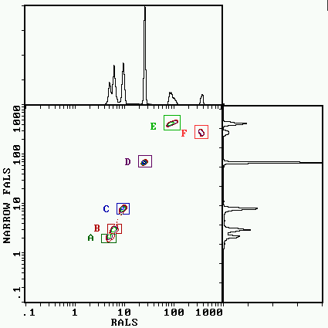 | Figure 4  The distribution of latex beads at different light scatter angles: The alphabetical order of the regions from A to F in the contour plots matches the increasing diameter of 350 nm, 380 nm, 500 nm 660 nm, 1160 nm and 2230 nm. The relative positions already indicate non-linearity between narrow FALS and bead diameter.

Signal processing: Bacterial discrimination, back-gating
Using clean beads, discrimination on fluorescence gives a pretty clean picture. That is more likely to occur when triggering on scatter. The main sources of interference are particulate matter in sheath or sample in form of precipitation which require filtration. In case of the sheath fluid it is important to have a sterile filter close to the flow cell, as particles are released from aged tubing. Noise can be generated from dust stuck in the light path increasing the constant photon background leading to a noisier detector, and little pieces of dust can even generate modulated photon flow.
To familiarise yourself with instrument performance it is a good idea to play around with ‘fat cells’ from a culture. At high enough concentrations interference problems with non bacterial events are rare. At lower concentrations the biggest contribution of non-bacterial matter is usually the sample. This can be precipitates from the growth medium or micelles or precipitates that form as a result of substances added to the sample like antibiotics. Thus it is important to be able to discriminate bacteria from non-bacterial matter. Apart from using supravital DNA stains this is best achieved by analysing cluster formation in parameters independent from the fluorescent plot under investigation (Figure 5). As modern cytometry software packages are more powerful, it is a good idea to set up one set of displays of scatter (y-axis) versus fluorescence (x-axis) to look at data clustering (see Figure 5c).

a | Figure 5  Bacterial discrimination against interfering particle background: (a):Light scatter density plot with diffuse clustering. (b): Fluorescence density plot shows multiple populations. (c): Correlation of fluorescence and scatter gives already information of clustering in one independent parameter. (d): Scatter distribution of the negative events shows continuous wriggely tail towards the origin (micelles left) and precipitates and debris (right). (e): shows a complex cluster of stationary E.coli clearly separated from the background.
b | c
d | e

Light Scatter measurements : Opportunities and limitations
Detection sensitivity by light scatter is limited by the optical arrangement. Reports about the correlation between scatter measurement and cell volume are conflicting (Allman et al. 1993; Boye and Steen, 1993). Whilst the correlation between RALS and particle cross section reached r²=0.9997, Figure 6 already demonstrates that the situation is more complex. The bacteria appear in the same narrow FALS area as the 500nm beads (Figure 6a, Y-axis), but lower than the 350nm particles in RALS (Figure 6b, X-axis). In the end this is not too surprising as, apart from particle size, scatter signals depends on cell shape, refractive index and extinction coefficient. But still, the information obtained represents an important information to indicate changes in morphology and correlation can be obtained on pure cultures in short term observations were changes in refractive index, OD and aggregation are not critical (Davey et al. 1993; Durodie et al. 1993; Wold et al. 1994).

(a) 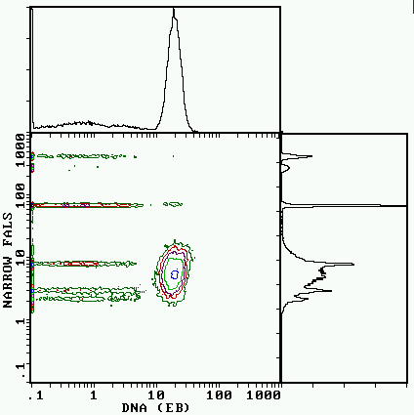 | (b) 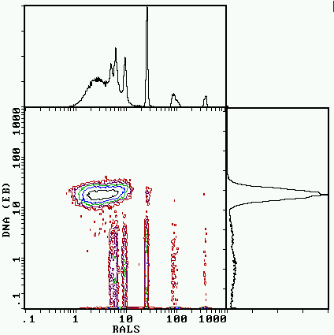
Figure 6
Light scatter signal of Peptostreptococcus anaerobis stained with ethidium bromide in comparison to a range of latex beads

The limitation in scatter sensitivity becomes more critical when looking at particles as small as elementary bodies of Chlamydia trachomatis. This is demonstrated in Figure 7, where discrimination on scatter only did not resolve the particles of interest. This is another example demonstrating the importance of multichannel discrimination.
As already mentioned in the previous section, backgating on scatter can help confirming populations. It also can help to achieve cluster differentiation as for example with the spores in Figure 8 or as described by Allmann et al. potentially together with stains for DNA or membrane potential for species differentiation under controlled growth conditions (Allman et al. 1993).

a 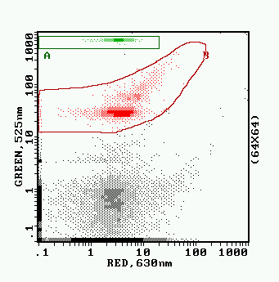 | b 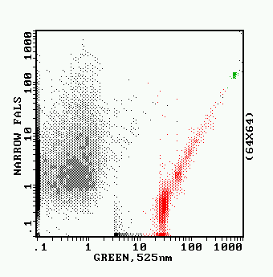
c 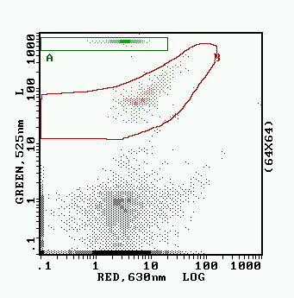 | d 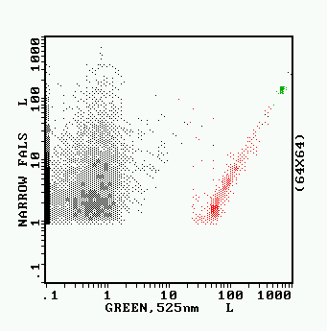
Figure 7
The requirement for multiparameter thresholding for the detection of Chlamydia trachomatis : Culture supernatants of C.trachomatis infected McCoy cells were incubated with FITC labeled antibody as described in 3.4.4. Detection was based on the simultaneous discrimination on both, FALS and green fluorescence. Threshold or trigger-levels were set to produce a background detection rate of less than 50 counts per second. Elementary bodies in picture a of green antibody fluorescence (Y-axis) versus red DNA stain (X-axis) are highlighted by region B. The DNA signal of the smallest population was equal to the background noise (bottom left cluster). In picture b this population lies also below the noise threshold of the forward scatter (Y-axis) of channel 1. The effect of discrimination of forward scatter only is shown for the same sample in pictures (c) and (d). The discrete populations of the elementary bodies creates the false impression that all the elementary bodies are detected, as the smallest detected cluster is separate from the background.

a: 5 minutes germination | b: 60 minute germination
c: 90 min germination | Figure 8  Germination of Bacillus cereus observed by ethidium bromide staining: Spores from a frozen preparation in distilled water were diluted in Brain Heart infusion and kept at room temperature. Samples were taken into DBS_{AT} immediately, after 60 and 90 minutes, sonicated for 30 seconds in the hot spot of an ultrasonic waterbath and stained with 5µg•ml⁻¹ EB. The isometric display has the origin in the top corner. The Y-axis (pointing to the right) represents Narrow FALS and the X-axis (pointing to the left) the red fluorescence of the EB. Initially most spores form a uniform cluster in the green region with only very few EB positive events (pink region). The blue region represents debris (a) and capsular material separated from the spores by the sonication (b,c). Whilst the germinating spores initially decline in FALS signal, the signal increases again together with an increase in EB fluorescence.

Sorting bacteria : Instrument preparations and sorting
In principle the same as for mammalian cells, only that you can use antibiotics as a back up to prevent contamination. As some commercial sheath liquids contain antimicrobials, standard buffers should be used as sheath liquid. The other main consideration is the handling / sorting of biohazard material which has been recently adressed by ISAC (Schmid, 1997)
The installation of self-bleeding disposable filter cartridges (Millex GV, Millipore, Bedford Massachusetts, USA) in close proximity of the flow cell is the most valuable adaptation. As filters can break through and become contaminated backwards through the pipework, the cartridges are replaced on any sorting day. When vacuum is applied to the flow cell, the remaining sheath line can be cleaned very effectively by sucking up 50ml of a 50% Domestos solution (1:1 with distilled. water), as there are no pressure sensors or dead spaces between the filter connections and the flow cell. The luer connectors are then rinsed with 10ml 75% isopropanol also sucked through the pipe and a new filter is attached and labelled with a date. The sample line is also treated by running 2ml of 50% Domestos followed by an isopropanol rinse. To rinse the sample rod between samples with distilled water, a 50ml syringe with an end point sterile filter is used.

!! For reasons of fire-safety it is important to ensure that the high voltage deflector plates are switched off all the time whilst instrument disinfection takes place.!!

The handling surfaces in front of the instrument and the sorting area are also sprayed generously with 75% isopropanol, including the deflection plates, and excess liquid is wiped away.
To minimise the risk of splattering droplets, which can give rise to aerosol formation, it is important to ensure that the waste stream of the system hits the waste collector at the sloped edge. When hitting a surface perpendicular to the droplet flow, splattering is more likely to occur. Foam in the waste collector can also lead to splattering. It can be removed by a drop of ethanol delivered with a pasteur pipette.
After all that preparation contamination is less likely to come from the instrument but from handling the broth or agar plates. Therefore it is useful to have a cover above sort compartment and to leave lids on plates and Petri dishes until the sort starts. As the Autoclone® in the Elite moves the plates further then the sort compartment, a lid or cover should also be installed above that moving space. Use of gloves and intermittent disinfection of the hands can also reduce the risk if contamination.
Whilst the Autoclone could easily be adapted to take Petri dishes, their use for growth support can only be recommended for non-injured cells. Sorting 3nl liquid is not enough to wet the plate sufficiently, thus giving rise to additional osmotic and oxidative stress. However it gives an excellent opportunity to check for contamination by location of the sorted colony or more accurate enumeration if more than one cell is sorted as up to three cells / colonies can usually be distinguished. In addition one can obtain basic differentiation and use them to convince the microbiologists that what was a blip on the screen gives rise to their beloved little colonies. 96 well plates allow much better recoveries but detection of contamination is merely impossible.
Independent from the use of dish or plate, it is important when sorting subpopulations to have a selection of each subpopulation on every plate. This avoids falling for sorting drifts or changes occurring in the culture.

Functional and differential labelling of bacteria

Bacterial enumeration: Sample handling, disaggregation and counting methods.
All microbial detection systems that rely on cell replication are limited by our ability to get bacteria to grow. In natural populations symbiotic partners can be required or anaerobe micro-environments might exist that prevent accurate plate counts as some cells will only grow anaerobe, some only aerobe and some under both conditions. Thus correct counts, which detect healthy, injured, dormant, 'viable but sometimes-non-culturable' as well as truly dead bacteria can only be obtained by direct optical methods.
The major obstacle is to differentiate the bacteria from other debris in a sample. This is best achieved by DNA stains in combination with light scatter measurements. Special care has to be taken to avoid interference by DNA fragments and micelles that can pick up the dyes non-specifically. Double labelling with two fluorochromes of different membrane permeability allows more stringent bacterial discrimination of 'DNA surrounded by an intact cell membrane'.
Because of the counting error (n^0.5) it is necessary to investigate 100 events to achieve 10% variation. At 1000 events the coefficient of variation reaches 3% and above 5000 it goes below 1%. Thus because of the speed of analysis and the degree of automation, flow cytometry is preferable to image cytometry for enumeration unless spatial information is required.

Counting methods
- Fixed volume counting or volume integration :
This method is used in most haematology analysers. The volume measurement is achieved by two contact electrodes acting as level sensors in a known geometric set-up (Partec CAII) or by loading a cavity in a ceramic valve (Abbot Cell Dyn 3000, Coulter XL) or a loop made of tubing as done in high pressure liquid chromatography instruments. In all cases all events within the volume are measured.
Count or events can be lost by system leaks in particular when handling small volumes, flow restrictions or because of electronic dead times.
- Time integration :
This approach is based on the assumption of a constant volume flow over time. It is best achieved by (syringe) pumps delivering the sample. Such systems are implemented in the Ortho Cytron absolute and the former Skatron Argus flow cytometer now Bio-Rad Bryte HS.
Limits are as above, pump speed instabilities and sample carry-over. If differential pressure is used to transport the sample additional implications can arise from restrictions in sample or sheath flow, pressure fluctuations and changes in liquid viscosity due to additives or temperature.
- Spiking with reference particles (ratiometric counting) :
Mixing known volumes of solutions of reference particles and unknown sample allows calculation of absolute counts from the measured particle ratio. This method can be used with all cytometers. It corrects for system dead times and the variations in sample delivery rates as discussed above. The tight cluster of beads also serves as an on line alignment control, particularly important when measuring environmental samples that are more likely to block the flow path. Ratiometric counting also allows a certain freedom of sample manipulation in terms of washing and dilution steps. Becton Dickinson, Ortho Diagnostics and Coulter Corporation have released counted bead standards for use in clinical immunology and the System II software of the Coulter XL® has already implemented this method to give a direct output in absolute counts. Manual calculation can be obtained following the formula below:
$$\text{Sample conc}\text{.}=\frac{[\text{ref}\text{.}\text{volume}]´[\text{sample predilution}]´[\text{sample count}]´[\text{ref}\text{.}{\text{concentration ml}}^{\text{-1}}]}{[\text{sample volume}]´[\text{ref}\text{.}\text{predilution}]´[\text{ref}\text{.}\text{count}]}$$

The high number of counts achieved by flow cytometry make the technique superior to others with the regard of counting accuracy. By careful pipetting technique and using 0.05% Tween 20 to avoid cell sticking we could achieve counting variations within 1% of the expected numerical counting error.
The detection sensitivity of optical systems is limited by the statistical abundance of an event and the signal intensity separating the event from background noise. To identify a cell cluster it is desirable to have at least 100 cells in it. Thus if there is one organism per µl in the final sample volume, 100µl have to be measured. Relative frequency is another limit to the measurement. To detect a log 3 reduction equivalent to an event frequency of 0.1% 100.000 events need to be screened to see 100 wanted cells. Good signal to noise ratio is therefore important, as, at lower relative frequency, the labelled cells are end up within the standard deviation of the unlabelled events.
Signal to noise ratio is also limiting the speed of measurement, as with increased sample / volume throughput the variations broaden but in particular the background fluorescence increases due to free fluorochrome. With flow rates currently operating around 10µl×min⁻¹ this leaves a practical sensitivity of approximately 10^3 within 10 minutes. Lower concentrations require patience or pre-enrichment by physical or biological means.

Sample disaggregation
Single cell suspensions are essential for any form of accurate counting. Aggregates only give rise to one single colony or event. If for example one cell in a triplet is positive for a dead cell marker the whole aggregate is registered dead but will grow when sorted onto agar plates. This is a potential problem with samples like skin flakes, as hundreds of bacteria can be attached to a single flake.
Cells can be dissaggregated by either chemical or mechanical methods. Mechanical methods have a broader application spectrum but can lead to problems with filamentous organisms. Shearing by needles leads to problems with clogging and is very tedious. Shearing with homogenisers is difficult with small volumes and causes problems with foaming and sample carryover.
Ultrasonic treatment is the most convenient method, but it is important to apply reproducible energy levels. The geometry of the set-up and the material of the sample container has to be taken into consideration. When using a probe, energy loss can occur by coupling to ice cold water surrounding the sample container or by air bubbles trapped at the bottom of pointed vessels. Transmittable energy in an ultrasonic waterbath is sensitive to the level of water, its temperature and dissolved gas as well as its cleanliness. Soft container materials like polypropylene do absorb the energy in both systems.
Figure 9 shows an optimum recovery of cells when using a two minute sonication time at a 2µm amplitude. From the decrease of total cells and the relative increase of permeabilised cells we can see that sonication times above 10 minutes cause destruction of intact cells. The decrease of plate counts also suggests that cell damage occurs. 1µm sonication appears to give a wider 'window of constant recovery, but is more difficult to set up and the longer sonication time required makes it less feasible in practice.
Despite the disaggregation caused by the pipetting of the samples, sonication generated on average an increase of counts by a factor of 4 to 7 for cytometric counts and 6 to 8 for plate counts of smooth surface plaque. Immunofluorescent detection of Strep. sanguis resulted in a 12.2 fold increase compared to a 6.3-fold increase in total counts demonstrating species specific variation in aggregation.
Light scatter distribution usually tightens upon sonication and background separation improves. Rod shaped Actinomyces did show no increased sensitivity to sonication, but care needs to be taken when looking at filamentous organisms. Looking at older plaque samples has already shown that mechanical disaggregation is not always sufficient to disaggregate samples. Sonication in the presence of stains can lead to uptake of membrane impermeable dyes like PI and loss of antibody fluorescence as well as flagella.

Protocol for counting using a single colour stain:

The following protocol was used for the investigations into the sonication effects:

Sonicator: 3mm exponential probe at 23 kHz (MSE Soniprep 150).
Instrument settings: 1 and 2 µm amplitude for various time length.
Sample container: Disposable polystyrene 7ml flat bottom containers sonicated against air. The probe tip was 5mm below the liquid surface of a 2ml sample.
Samples: 24 hour bacterial plaque scraped with a wooden applicator and dissolved in 5ml of Dulbecco's phosphate buffered saline (DBS) split into 2 volumes at 2ml. Cultured organisms were grown in supplemented brain heart infusion containing 1% sucrose (S.sanguis, Actinomyces A8).
Staining: 20µl sample were diluted at various time points into 80µl DBS. 20µl of that solution were mixed with 20µl 0.66µm yellow-green fluorescent beads (Polysciences, Warrington, PA, USA) at 1×10⁸ml⁻¹ in DBS_{AT} containing 0.1%azide and 0.05% Tween 20 for counting, 10µl ethidium bromide (EB) or propidium iodide (PI) at 1mg/ml (Sigma, Poole, UK) and 150µl DBS_{AT}. After 15 minutes the samples were diluted in 1.8ml DBS and measured in the EPICS XL flow cytometer, with the first tube (EB) giving total number of bacteria and the second tube (PI) reflecting the permeabilized fraction.

Limitations:
Under some conditions the DBS can cause precipitation of sample components. If other buffers are used it is important to include the azide and Tween to inhibit dye extrusion and cell sticking.
Azide is not always sufficient to block dye extrusion, thus needs to be tested for the particular application. Mild heat (45°C) (Sahar et al. 1983) or storage on ice (Jernaes and Steen, 1994)can facilitate EB uptake.

a
b
Figure 9
Effect of disaggregation on the recovery and enumeration of bacteria from dental plaque: The 5 fold increase in FCM counts of over the 2 minute sonication period (a) coincides with the highest recovery in graph (b). The decrease in the relative proportion of PI positive cells in (a) is a consequence of separating aggregates as described in the text. The loss of cell numbers at eight minute sonication at 2µm amplitude is apparent on both graphs.

The viability concept
Figure 10
Viability measurements in their functional context: Reproductive growth as the most stringent proof for viability requires metabolic activity and in turn membrane integrity. In a lot of cases this function can not be measured due to irreversible DNA damage, fastidious growth conditions, lack of symbiotic partners or extremely slow growth. Detection of metabolic activity is less stringent but suggests the absence of cell death. Whilst it does not warrant reproductive growth, this function might be sufficient to generate unwanted effects such as food spoilage or accumulation of toxins. In cases of injury, dormancy or extreme starvation metabolic functions might be below detection limit. Membrane integrity demonstrates the protection of cell constituents and its potential to generate gradients thus it’s potential capability of living / repair. It also separates bacteria from other organic matter and debris. Cells without an intact membrane can not maintain any electrochemical gradient and can be classified as dead cells. As their structures are freely exposed to the environment they will eventually decompose.
The problem with the measurement of viability is it’s definition. The Oxford dictionary phrases it as: ”capable of living or existing in a particulate climate, capable of maintaining life or able to germinate” Terms like vitality also give no more stringent definition. In the end, the question behind viability is a matter of ‘life and death’. Life is described as: “The condition which distinguishes active animals and plants from inorganic matter, including the capacity for growth, functional activity and continual change preceding death”. Whilst the principle of death becomes a bit difficult with micro-organisms who actually divide into the next generation, the description of death as: “The final cessation of vital functions” also focuses mentions functional activity. Thus differentiation from organic matter and the detection of biological functions are the two most important criteria that define viability. The more complex the function, the more stringent it is as a measure of viability. The functional measurements available and the resulting differentiation has lead to a ranking system of functional states (Figure 10) also reflected in the subheadings in the chapters on viability. Cytometry allows to differentiate stages far beyond the classical microbiological definition of cell growth.

Reproductive growth as the most stringent proof for viability requires metabolic activity and in turn membrane integrity. In a lot of cases this function can not be measured due to irreversible DNA damage, fastidious growth conditions, lack of symbiotic partners or extremely slow growth. Detection of metabolic activity is less stringent but suggests the absence of cell death. Whilst it does not warrant reproductive growth, this function might be sufficient to generate unwanted effects such as food spoilage or accumulation of toxins. In cases of injury, dormancy or extreme starvation metabolic functions might be below detection limit. Membrane integrity demonstrates the protection of cell constituents and its potential to generate gradients thus it’s potential capability of living / repair. It also separates bacteria from other organic matter and debris. Cells without an intact membrane can not maintain any electrochemical gradient and can be classified as dead cells. As their structures are freely exposed to the environment they will eventually decompose.
From a product safety point, the only safe cell is a truly dead cell as in some cases even the accumulation of metabolites from non-growing but metabolising organisms can be sufficient to spoil a product. Apart from the potential production of toxins, those cells can also spread plasmids that can encode for their production or for other undesired products.

Reproductive growth
Proliferation can be easiest demonstrated by counting bacteria against reference beads. With counting errors below 5% (even on sub-populations in a mixture) minor changes can be detected. The major limitation on accuracy is the ability to obtain single cell preparations.
Cell tracking using a covalent coupled label allows to demonstrate culture heterogeneity as well as cell division. Growth can be followed by increase in light scatter or volume with biomass accumulation followed by halving fluorescence intensity. Important factors are high initial labelling intensity and low coefficients of variation to allow visualisation of multiple division cycles. The use of Carboxy-Fluorescein-diAcetate-Succinimidylester (CCFAS) allows a gentle coupling step in medium, as both , the fluorochrome as well as the succinimide group only become activated inside the cell. It also only labels esterase positive cells, which makes it a viability stain in it’s own right.

A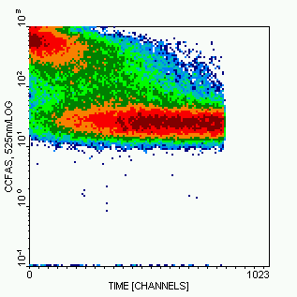 | b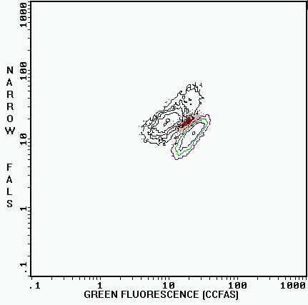
Figure 11
Cell tracking of Listeria innocua labelled with diChlor-CarboxyFluorescein-diAcetate-Succinimidylester (CCFAS) in Tryptic Phosphate Broth: 1 ml of a 24 hour culture was pelleted and resuspended in 1 ml fresh filtered TPB. 50 µl of this sample were mixed with 50 µl CCFAS, (100 µM in distilled water) and incubated for 30 min at 25°C. Cells were washed two more times in 1 ml TPB, resuspended in 500 µl TPB and grown at 25°C. Cells from a one day old stationary culture were stained with CCFAS for 30 minutes and incubated in TPB at 25°C. Bacteria were measured continuously from 3 to 10 minutes (a) and then at multiples of 30 minutes. The overlay of NFALS (Y-axis) versus CCFAS fluorescence (X-axis) is shown in (b) for t= 30 (coloured lower contour plot) 120 (dot plot) and t=180min (black contour plot) (b).

Metabolic activity measurements
As said above, metabolic activity noes not warrant reproductive growth but is the next best criteria towards it.

Energy independent measurements, enzyme activity:
Whilst the synthesis of enzymes obviously requires energy, enzyme reactions usually don’t. This fact has been most noticeably been exploited in the ELISA technology or by the use of enzyme systems
Esterase activity is probably the most common form of metabolic activity measurement used (Diaper and Edwards, 1994; Breeuwer et al. 1995; Porter et al. 1995; Edwards, 1996) . It can be classified as energy independent as the enzyme will remain functional in the cells as long as it is retained by the intact membrane and protected from the environment. Our own unpublished studies have shown that H₂O₂ killed cells maintain esterase activity for over a week, and Colin Frickers team at Thames Water in the UK has shown the same for gamma radiated cells for over two weeks indicating its long persistence.
Limitations for the esterase stains originate from poor dye uptake, but mainly active dye extrusion (Molenaar et al. 1992). Loading should be done below pH 7 to avoid dye cleavage, and removal of extracellular esterase activity is immanent. Extrusion can be overcome by the addition of metabolic inhibitors or the use of dyes that crosslink inside the cell.
Figure 12 shows that even when using the covalently binding CCFAS on bacteria from dental plaque, there are still unlabelled cells that can grow when sorted onto agar plates. Whilst certainly dye loading could still be improved by permeabilisation of the outer membrane and other methods, it has to be considered that highly starved or injured cells might not possess sufficient functional enzyme to generate enough signal for detection.
In principle the measurement of dehydrogenase activity (Rodriguez et al. 1992; Kaprelyants and Kell, 1993a; Yu and McFeters, 1994; Huang et al. 1995; Nybroe, 1995) by tetrazolium (TZ) dyes is also energy independent. Because of their redox-potential they act as electron acceptors down to the level of NADH₂, only exceeded by Alamar Blue (resazurin) that can also accept electrons from the cytochromes. Unfortunately neither the electron negativity nor the lipid solubility of the TZ’s can explain the variability of their reactivity in different conditions or with different organisms (Thom et al. 1993; Bovill et al. 1994; Walsh et al. 1995), a factor that has been exploited for differentiation of different bacteria (Barnes, 1956).
Even the cell associated nonfluorescent formazan precipitation can be used to differentiate cells by light scatter. This precipitation so is also the big disadvantage of the stain as it therefore also precipitates in permeabilised cells that have still an active respiratory chain, where esterase substrates would leak out. The long persistence of respiratory and other enzymes on the membrane has been exploited in the SPRINT recovery medium [Oxoid, Basingstoke, UK], where membrane preparations are used to remove oxygen and toxic oxygen species from the medium. The tetrazolium dyes can also be reduced by media components (Thom et al. 1993) and the fluorescent CTC seems to be sensitive to phosphate above 10mM (Smith and McFeters, 1996). The disruption of the electron transport chain caused by TZs makes the dyes cytotoxic, thus limiting their application (Ullrich et al. 1996).

A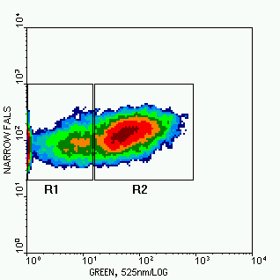 | B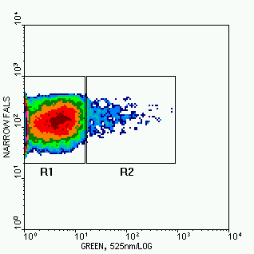
c 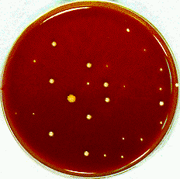 | d 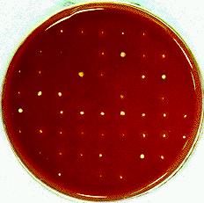
Figure 12
Esterase activity and reproductive viability in smooth surface plaque: Cells were sonicated with the probe and stained for 15min at 30°C in DBS with 33 µM CCFAS(a) and CFA (b). CCFAS negative (c) and CCFAS positive cells (d) were sorted onto SBHI-blood agar plates and incubated for 48 hours at 37°C 5% CO₂.

Energy dependent measurements:

Enzyme activity:
As mentioned above, loading at low pH facilitates dye loading as the substrate remains neutral outside the cell. If done at pH 4 as in the case of the Chemchrome B kit from Chemunex, it leads to total quenching of the dye fluorescence outside the cell. It also ensures that dye cleavage and fluorescence in cells that can not maintain their intracellular pH is inhibited, thus making the stain energy dependent.

Membrane potential:
Membrane potential (MP) is the most ‘abused’ measurement for metabolic activity in microbial flow cytometry. The principles behind it are best explained in Shapiro’s handbook (Shapiro, 1995). Commonly used probes for estimating the membrane potential (ψ) are charged lipophilic dyes, such as carbocyanines, rhodamine 123 or oxonols. These dyes, that can readily cross the membrane and therefore follow the membrane potential according to the Nernst equation, are called distributional probes.
$y_{i}−y_{o}=\frac{\text{RT}}{\text{zF}}´\text{ln}\left(\frac{a_{o}}{a_{i}}\right)$ (1)
or
$\frac{a_{o}}{a_{i}}=\text{exp}\left(\frac{\text{zF}}{\text{RT}}\left(y_{i}−y_{o}\right)\right)$ (2)
Equation 1
The Nernst equation: ψ = electropotential, _{i} = inside, _{o} = outside, a = active (diffusable or unbound) concentration, R = Reynolds constant, T = absolute temperature, z = charge, F = Faraday constant

Depending on the charge of the probe (anionic or cationic) they accumulate in polarised or depolarised cells as shown in Figure 13. Because of the diffusion times involved, these probes have a slow (seconds) response times. The way that distributional probes generate such strong signal is by binding inside the cell. The cytoplasm acts as a sink for the fluorochrome that has entered the cell. The dye is thereby removing it from the bulk of free diffusable dye molecules distributing according to the Nernst equation and more dye can enter the cell. As also shown in Figure 13 at high dye concentrations the accumulation becomes potential independent as eventually all dye binding cites become saturated and the staining becomes independent from the membrane potential as all binding sites become saturated. From the discussion above it becomes apparent that apart from the actual membrane potential, signal intensity depends on the cell volume and the number of intracellular binding sites available. As those two parameters can change with growth conditions over time, slow changes of signal (hours) as observed for example in recovery of starved bacteria (Kaprelyants and Kell, 1993b) have to be treated with caution.
The following key points should be considered when attempting membrane potential stains:
- It is important to recognise that membrane potential stains are equilibrium stains. Thus it is important to use them as such with well defined concentrations and not to wash the samples.
- As mentioned above, the fluorescence is dependent on the available binding sites in the cell, but also the total number of binding sites in the sample e.g. total number of cells and binding sites in the medium (Kaprelyants and Kell, 1992; Shapiro, 1995; Müller et al. 1996). Bis-Oxonol (BOX) for example is difficult to use in the presence of Tween as it separates into the micelles. It also interacts with gramicidin (López-Amorós et al. 1995), reducing the available dye concentration.
- Changing bacteria into a different medium for staining also alters the MP. As described in Shapiro’s book, this can be used in an elegant way to check the contribution of various electrolytes on the membrane potential. Thus choice of the staining buffer is very important.
- MP stains tend to require permeabilisation of the outer cell membrane of Gram- (Shapiro, 1990a; Shapiro, 1990b; Kaprelyants and Kell, 1992; Shapiro, 1995). From our experience it is definitely required to allow uptake of the highly lipophilic BOX, but might not be necessary for all stains (Monfort and Baleux, 1996; Müller et al. 1996). To avoid the side effects of EDTA, polymixin nonapetide [Sigma, Poole, UK] can be used for that purpose.
The intracellular accumulation of cationic probes like rhodamine or the carbocyanines can be severely impaired by active dye extrusion systems. These pump systems are actually a good measure for metabolic activity themselves.
Double labelling with BOX and PI for mixtures of untreated and heatfixed dental plaque (Figure 14) showed the same pattern as for Micrococcus luteus. Whilst the freshly killed cells emitted a high BOX fluorescence, the originally dead cells marked by region R1 also only gave weak signals.
Compared to the ratiometric membrane potential measurement with DiOC2(3) (Novo et al, 1999, Shapiro and Nebe-von-Caron, 2004) the measurement with BOX gives more a yes no answer for MP. However if it works in a particular application it leaves you a channel free for other measurements.

a: 0.2µM RH123  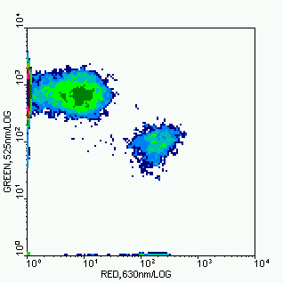 | b: 1mM RH123  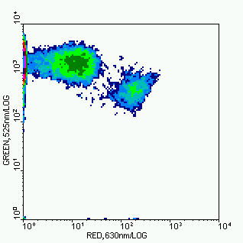
c: 2mM RH123  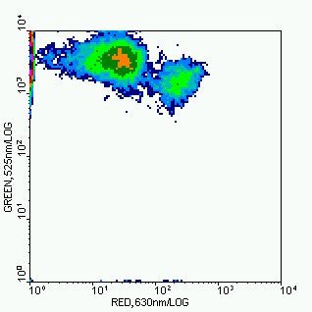 | d: 1µg×ml⁻¹ BOX  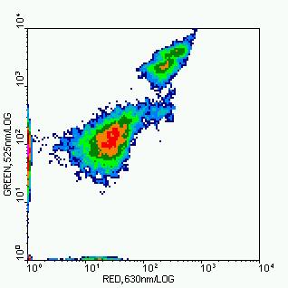
Figure 13
Comparison of membrane potential measurements by anionic bis-oxonol (BOX) and the cationic RH123 and the effect of dye concentrations: A lyophilised sample of Micrococcus luteus was reconstituted and incubated in Nutrient Broth for 2 hours at 25°C. A mixture of heat fixed and untreated cells was labelled with RH123 (a,b,c) or BOX (d) all counterstained with 10µg·ml⁻¹ PI. All pictures show the green membrane potential stains on the Y-axis and the red PI stain on the X-axis. Measurements were taken in equilibrium with the stains.

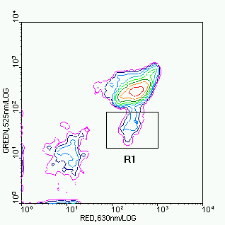 | Figure 14  Correlation of BOX and PI staining on dental plaque: Mixture of untreated and heatfixed plaque stained with 0.1 µg BOX and 5 µg·ml⁻¹ PI. Whilst the freshly permeabilized cells give strong fluorescence with PI and BOX, the PI positive cells of the untreated plaque sample (R1) give only a weak BOX signal.

Dye extrusion pumps
As mentioned above, labelling with membrane potential probes can suffer from active dye extrusion. The rhodamine measurements with Listeria shown below demonstrates that effect. The high dye concentrations under which the bacteria were grown was sufficiently in excess to stain cells independent of their membrane potential as validated by microscopy, so the dye had been internalised. Loss of fluorescence upon dilution could only be detected in the 19 hour sample, where the extrusion process had slowed down. The presence of pumps was initially identified as a major obstacle, not only for obtaining reliable estimations of the membrane potential. This suspicion was confirmed by searching for evidence for dye extrusion systems in the literature (Lambert and Le, JB, 1984; Midgley, 1986; Krishan, 1987; Midgley, 1987; Miyauchi et al. 1992; Molenaar et al. 1992). The work of Midgley seriously questions the use of lipophilic cations (fluorescent or not) for membrane potential estimates as they are subject to an H⁺/Probe⁺ antiport system in E.coli. The fact that the stationary cells still accumulate RH123 but have stopped its active extrusion and allows the use of these pumps to assess the proton-motive force that is supposed to drive them.
Table 2 demonstrated the what you measure is what you get (WYMIWYG) effect. The different staining pattern of the exponential growing cells in the respective solutions emphasises the importance of the staining solutions. Thus if one wants to measure the pump activity under culture conditions it is best to measure as close as possible to it.
Unfortunately the disadvantage of the cationic stains is the lack of discrimination between pumping and depolarised cells. The use of BOX to measure depolarisation offers a valid alternative as in allows to measure depolarisation which is more likely to occur once the proton gradient has been exhausted. The presence of the pump can than be measured with a corresponding anionic DNA stain like ethidium bromide, which allows the simultaneous measurement of both parameters.

Table 2
RH123 staining of exponentially growing and starved cells in different solutions. 5 hour cultures from an over night broth and cells from 24 hour cultures stored at 4°C for 10 days were washed and stained in the respective buffers for 20min in 5 µM RH123 and diluted 1:150 in DBS
STAINING SOLUTION | EXPONENTIAL CELLS | STARVED CELLS
50mM TRIS pH 8 | + | +
DISTILLED H₂O (A.D.) | + | +
A.D. + 0.2% GLUCOSE | + | +
TPB CULTURE MEDIUM | - | +
DBS pH 7.3 | - | +
0.85% NaCl | - | +
0.85% KCl | - | +

Figure 15
Growth curves of Listeria innocua in the presence of 0, 5 and 10 µM rhodamine 123 (RH123). Over night cultures cells were diluted in fresh TPB and loaded into the wells of a Bioscreen for growth analysis.

A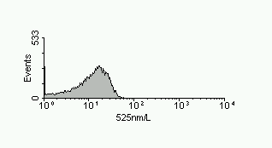 | b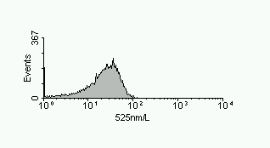
C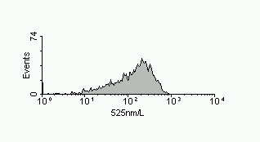 | d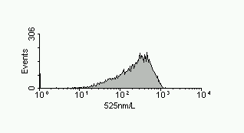
E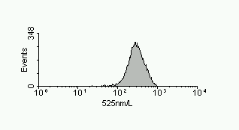 | f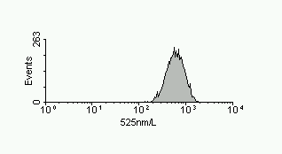
Figure 16
RH123 fluorescence profiles of Listeria innocua grown in the presence of 5 (a,c,e) and 10 µM RH123 (b,d,e). Cells where taken at 16, 17 and 19 hours of culture representing late exponential (a,b) early stationary (c,d) and late stationary (e,f) growth phase. The cells were diluted 1:150 in TPB pH4 and measured immediately.

Biosynthesis
The first measurements on microbes were all about nucleic acid synthesis and content (Hutter, 1974; Bailey et al. 1977; Paau et al. 1977). When handling pure cultures this is an excellent measure for biosynthesis. It has been used early on for monitoring toxicity or antibiotic susceptibility (Hutter and Oldiges, 1980; Steen et al. 1982) and is also used in microbiological process control (Ackermann et al. 1995; Muller et al. 1995). Apart from measuring increase in nucleic acid or the number of initiated replication forks, the uptake of Bromodeoxyuridine (BRDU) can also be measured (Srienc and Dien, 1992; Dien et al. 1994).
Another measurement for biosynthesis is the growth of bacteria in volume. This has been exploited by Gant et al to look at elongation in response to inhibition of cell division by antibiotics (Gant et al. 1993) and by Porter et al in response to growth stimulation in the presence of nalidixic acid based on the microscopical direct viable count assay (Porter et al. 1997). The latter would give an excellent basis for the cell sorting application to see if it would correlate it with culturability.

Membrane integrity
As mentioned above viability measurements should be aimed at differentiation of bacteria from other organic matter and demonstrate a biological function. The presence of DNA in all bacteria makes this an ideal staining target. If used on its own it can be confusing as signals can also be generated from other biological debris and dead cells. To overcome that limitation, Zweifel and Hagsröm have developed a protocol to harmonise DNA stain based counts with culture results by trying to de-stain such particles (Zweifel and Hagsröm, 1995). Combining DNA staining with testing for a selectively permeable membrane surrounding the DNA to add the information of the protective function of a membrane seemed to be a more sensible approach. The history of the DNA stains EB and PI as dye exclusion markers made them first choice for the use with a 488 nm excitation. The supravital staining characteristic of EB has been confirmed on azide inhibited cells and by counterstaining (Figure 17, Figure 18) and sorting techniques (Figure 19) (Nebe-von Caron et al. 1994; Nebe-von Caron and Badley, 1995), has also been observed by Jernaes and Steen (Jernaes and Steen, 1994).

a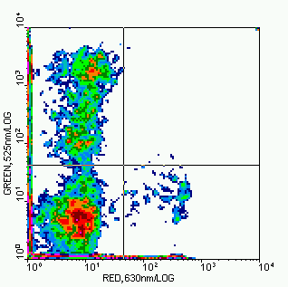 | b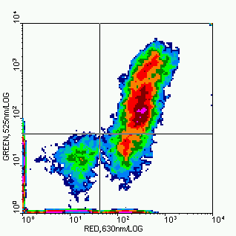
Figure 17
Comparison of esterase activity staining and membrane integrity. Bacteria from a mouthwash with sterile filtered distilled water (A.D.) were briefly sonicated in a waterbath and 200 µl, were filterwashed twice with A.D. and stained in 10 µM CCFAS in A.D. for 60 minutes followed by two more filterwashes. Cells were resuspended in 500 µl DBS_{AT} containing 2.5 µg PI (a) or EB (b).

Membrane integrity can be tested by the exclusion of high molecular weight molecules with intracellular target sites. Of the two nucleic acid stains ethidium bromide (EB) and propidium iodide (PI), commonly used as dye exclusion markers in mammalian cells, only PI is suitable for membrane integrity measurements. EB behaves like a supravital stain as it labels both intact and permeabilized cells, allowing the discrimination of non-bacterial matter. When trying to combine the DNA stain with phycoerythrin conjugated antibody staining the different compensation settings were required for EB and PI. Subsequent investigations lead to the finding that both dyes can be used simultaneously, as not only the orange part of the EB emission spectrum is sufficiently different to be separated from the PI but also the PI quenches the EB fluorescence. This is demonstrated on an artificial mixture of viable (untreated) and dead (heat fixed) stationary cultures of Listeria innocua. The PI labelling shown in Figure 18 a and b separated the bacteria into red-positive and red-negative clusters. with no signal in the orange due to correct compensation. The EB labelling in Figure 18 c and d shows unlabelled debris and micelles, a uniform red fluorescent cluster of bacteria and the more orange emission of the dye. The simultaneous application of EB and PI in Figure 18 e and f demonstrates the potential for the simultaneous discrimination of unlabelled debris by the absence of a red DNA fluorescence, and the differentiation of the intact and permeabilized cells based on the orange separation.
a 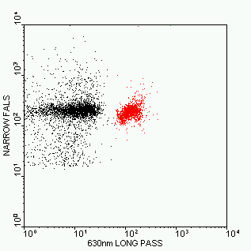 | b 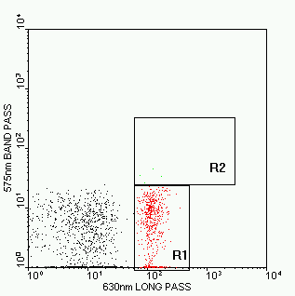
c 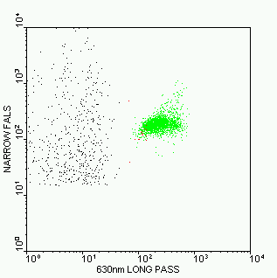 | d 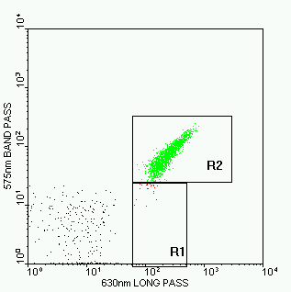
e | f 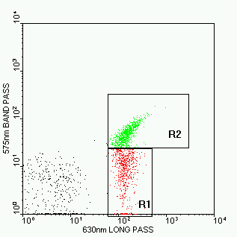
Figure 18
Membrane permeability for ethidium bromide (EB) and propidium iodide (PI): Mixtures of untreated and heat fixed starved Listeria innocua in DBS_{AT} stained with 10 µg·ml⁻¹ EB (a,b), 10 µg·ml⁻¹ PI (c,d) and a mixture of both dyes at 10 µg·ml⁻¹ each (e,f). Colour gating has been used to help differentiation of permeabilized cells (red=PI+), intact cells (green, EB+ only) and non-bacterial matter (black, unstained). Plot e illustrates the light scatter characteristics of interfering non-bacterial matter.

a 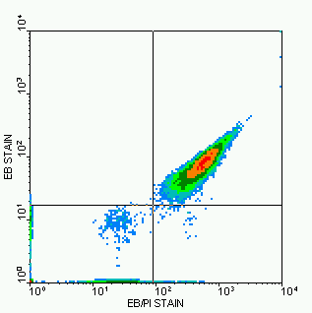 | b 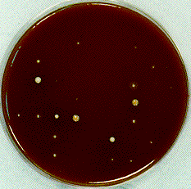
c 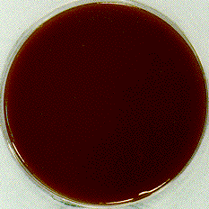 | d 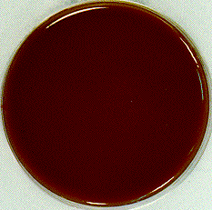
Figure 19
Single cell sorting of 48 hour dental smooth surface plaque stained with a mixture of EB and PI in DBS_{AT}. The sample was sonicated to yield single cells and sorted by triple droplet deflection to improve recovery directly onto SBHI agar plates using the Autoclone facility of the EPICS Elite as described in section 3.1.8. Plates were incubated for 48 hours at 37°C at 5% CO₂.
a | b
c | d
Figure 20
Extrusion of SYTO9 from 12 hour culture of Salmonella typhimurium heatinjured for 60 minutes at 54°C. Cells stained with 4 µl·ml⁻¹ LIVE/DEAD BacLight™ for 40 minutes in buffered peptone water, diluted 1:10 in buffered peptone water and measured at 5, 15 and 35 minutes (a, b, c) and compared with an EB/PI staining at 4 µg·ml⁻¹ each under the same conditions.
The quenching of the EB fluorescence by the PI is also a neat trick, as it allows to trigger for all cells on a single channel (red) or for intact cells only (orange). Dye quenching has also been described by Shapiro in his handbook (Shapiro, 1988) when labelling simultaneously with Hoechst and PI in dye exclusion test. Combinations of PI and DAPI have shown the same complimentary labelling (Matsunaga et al. 1995; Sgorbati et al. 1996) and are now commercialised by Biorad. The beauty of both systems is the absence of spectral overlap and the higher DNA specificity but they require UV excitation and multi channel triggering.
Unfortunately most cells actively exclude supravital stains like EB. Attempts to label viable E.coli failed, even with acridine orange which has the reputation of labelling everything. Dye extrusion can also be observed with the commercial LIVE/DEAD BacLight™ viability stain from Molecular Probes. The kit consists of a proprietary mixture of the supravital DNA stain SYTO9 and PI. If used at a concentration of 4 µl·ml⁻¹ all cells are green fluorescent and the permeabilized cells are green and red. When applied to heatinjured cells it showed comparable distributions for membrane integrity to the EB/PI stain (Figure 20). The SYTO9 stain has a good membrane permeability thus overcoming pump action at high enough concentration. Unfortunately the dye is unstable in aqueous solutions and becomes eventually membrane impermeable (Poot, 1994), perhaps explaining why is has been found to give inferior results to more established techniques (Langsrud and Sundheim, 1996; Jacobsen et al. 1997). It delivers good cluster separation but the spectral properties do not allow the use of a third colour excitable dye at 488 nm. The exact correlation of clusters other than the unstained population requires further investigation. With the premixed components from the old kit, the LIVE/DEAD BacLight™ stain did not give complementary fluorescence, e.g. either red or green. Thus in the absence of unlabelled cells aggregates of intact and permeabilised cells appear in the green+red (permeabilised) cluster. Compared to the EB/PI stain where aggregates appear orange+red (intact), this leads to an overestimation of permeabilised cells.

The high ranking of membrane integrity measurements in the determination of viability is based on two arguments:
- Cells that have lost it membrane integrity can not maintain any of the electrochemical gradients necessary to remain functional. Unless temporary permeability is deliberately caused as for example by electro- or chemoporation for inserting genetic constructs, such cells can be classified as dead. As their cellular structures are exposed to the environment, they will eventually decompose.
- The presence of a membrane with selective permeability indicates that the cytoplasm is still a separate entity from the environment and therefore has the potential to give rise to metabolism or proliferation. This can be important for risk assessment and also comes closer to a viability definition more appropriate for viruses that also do not show direct proliferation or metabolism.
The fact that the measurement does not require any activity by the cell also makes it favourable for the use with starved, dormant or injured cells that might require ‘resuscitation’ to regain more complex functions. In fact metabolic activity in form of dye extrusion pumps is the biggest hindrance to the detection of intact cells. The active extrusion pump for EB in E.coli has been described by Midgley and others (Midgley, 1986; Midgley et al. 1986; Midgley, 1987; Miyauchi et al. 1992) who investigated its coupling to transmembrane proton electrochemical gradient. Exclusion of other nucleic acid stains such as Hoechst by multidrug resistance pumps have also been described for mammalian cells (Krishan, 1987) highlighting the common nature of such systems and the associated problems. High dye gradients, increased temperature and the addition of detergents can be used to increase dye uptake. Alternatively the pumps can be deenergized by low temperature (Jernaes and Steen, 1994) or by addition of metabolic inhibitors such as azide, but the latter might be restricted to respiration dependent energy generation.
Propidium Iodide has so far remained the most reliable probe for membrane integrity. However it can be taken up by sublethally stressed cells (for example cells treated with sublethal doses of Nisin) and has also recently been shown to be taken up by some environmental organisms whilst actively growing (Shi et al, 2007).
Topro3 sometimes recommended as a PI substitute has also to be interpreted with care as some of the monomeric cyanine nucleic acid stains have been shown in mammalian cells to label cells not stained by PI (Buller and Godfrey, 2005, Idziorek et al, 1995)

Assessment of stress and injury by three colour multiparametric analysis

Changes in membrane functionality in starvation and germination
The simultaneous measurement of multiple functions such as dye extrusion, membrane polarisation and membrane integrity was tested for the first time on an old colony of S.typhimurium. Those cells were expected to provide natural heterogeneity and to undergo a ‘controlled cell death’ as much as to shut down energy dependent processes in a sequence. This was expected to allow a ranking of the parameters measured for viability and to give a meaningful correlation between staining and sort recovery. Equally, no rapid changes should occur with respect to their metabolic states (long lag times) resulting in stable distributions.
Figure 21 shows the cluster analysis for the triple staining with BOX, EB and PI (BEP). Colour gating was used to resolve clusters overlapping in the various displays. Red was used for red fluorescent events, green for green fluorescent events and blue was used for orange fluorescence negative events. Therefore nonfluorescent events appear in blue and the EB positive red and orange fluorescent events in red. The cells that have taken up EB and BOX (red, orange and green fluorescent) are marked in yellow. With the uptake of PI the cells loose their orange fluorescence. As they also positive for BOX those events fall into all three colour gating regions and are therefore displayed in grey. The events stained with BOX, but with neither of the DNA fluorochromes appear cyan in the display as they are colour-gated as blue and green.
Figure 21(a) shows the typical EB/PI distribution, with an red and orange negative cluster of EB extruding cells in quadrant 3, the EB positive red and orange fluorescent cells clustering in quadrant 2 (Q2) and the PI positive cells without orange emission in quadrant 4 (Q4). As can be seen from the colours, the events in Q2 and Q3 consist of two populations. Figure 21(b) has still two populations in Q2, but resolves the cells from Q3 picture (a) into two completely unlabelled cells (Q3) and a highly BOX positive clusters in Q1. These events are further characterised by their reduced light scatter signal compared to the unlabelled or DNA positive events (Figure 21(c)). The grey and the yellow labelled bacteria in Q2 show a double cluster with regards to the red DNA fluorescence.
Figure 22 shows the clustering of the populations in a display of orange versus green fluorescence. Whilst there are still 2 populations in the first quadrant, this image gives the best possible separation of all populations in a single bivariate plot. It is therefore also used to illustrate the sorting strategy of the various clusters, which consisted of the scatter gate to generate this dot plot and a small region set into the centre of each of the populations described below.
The bacteria excluding all stains showed the highest recovery with 91 % of the sorted cells. The cells that took up EB but still excluded BOX (red and orange fluorescent) followed with 85 % growth. Of the cells that took up EB and BOX but still excluded PI (green and orange and red fluorescent) only 35 % grew when sorted directly onto nutrient agar. Cells that stained for BOX and PI (red and green fluorescent) did not grow on agar plates, neither did the events that took up BOX only. For each cluster one sort run was also performed on a special recovery medium (NA_{OX}). The results are summarised inTable 3. The recovery for the unlabelled and the EB and BOX positive cells lies outside the double standard deviation of the sorts on normal NA plates.

Table 3
Recovery of S.typhimurium sorted from clusters of different staining patterns: The colour code corresponding to Figure 22. The percentage of recovery is based on the settings of 60 sorts per plate.
Staining Pattern | Location Figure 22  Colour Code | Colonies / plate  Nutrient Agar (NA) | Colonies / plate  NA_{OX}
triple negative | Q3, blue | 54;55;54;53 (91%) | 57 (95%)
EB+, BOX-, PI- | Q4, red | 50;50;53;52 (85%) | 50 (83%)
EB+, BOX+, PI- | Q2, yellow | 24;20;17;20 (34%) | 33 (55%)
EB-, BOX+, PI+ | Q1, grey | 0; 0; 0 (0%) | 0 (0%)
EB-, BOX+, PI- | Q1, cyan | 0 ;0; 0 (0%) | 0 (0%)

a 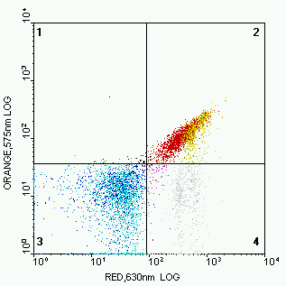 | b 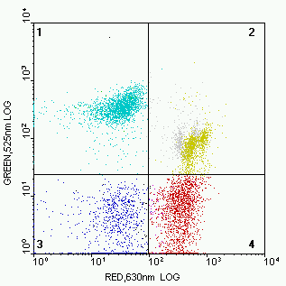
c 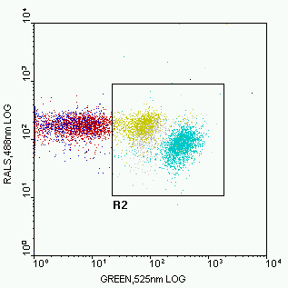 | Figure 21  Three colour fluorescence of bacteria from a 25 day old culture, stained simultaneously with BOX, EB and PI: Picture (a) and (b) show the cluster distribution of orange versus red and green versus red. Colour gates were defined with by regions of light scatter versus fluorescence as in (c), where even two separate green fluorescent clusters can be observed. Red fluorescent cells (PI or EB positive) were coloured red, green fluorescent cells (BOX positive) in green and orange negative cells (EB negative) in blue.

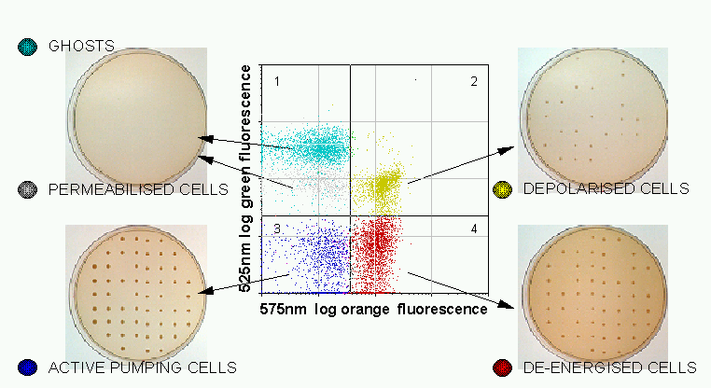
Figure 22
Single cell sorting of Salmonella typhimurium from clusters with different staining properties: A 25 day old colony from a previous sort onto nutrient agar plates was resuspended in DBS containing 0.1% peptone, 0.1% sodium succinate and 0.2% glucose. 10µl sample was diluted in 200µl DBS containing 4mM EDTA, sonicated for 10 seconds in the hot spot of an ultrasonic water bath and incubated with 2µl PI and EB at 0.5mg/ml each and 2µl bis-oxonol at 100µg/ml for 30 minutes at 25°C. Cells were directly sorted on Nutrient Agar plates

Previous experiments using multicolour staining with RH123, EB and PI (REP) had already revealed two populations if intact cells namely intact and depolarised and intact and polarised cells (Nebe-von Caron and Badley, 1995). The dye extrusion measurement possible with the BEP stain allows to distinguish at least three populations of intact cells. For starved cells pump activity seems not to have a dramatic effect on cell recovery. The big difference comes with the loss of membrane potential, but still a substantial number of those cells can be recovered. This confirms the statement of Kaprelyants and Kell (Kaprelyants and Kell, 1992) that depolarised cells can be recovered, but simultaneously disproving the common belief that the uptake of BOX resembles cell death (Jepras et al. 1995; Jepras et al. 1997). The differences in recovery between the two different media emphasises once more analytical distortion caused by the growth conditions.
In the hope to find similar energetic states in the germination process as seen in the case of bacterial starvation, the same staining and gating combination as used for the overgrown Salmonella was applied to spore samples. Apart from the pumping cells, the same clustering could be observed and the BEP triple staining method allowed a detailed division of steps within the germination process. It was found that all spores, whether germinated or not, take up BOX. However, the debris of similar forward scatter intensity show an even higher BOX fluorescence. This allows to separate the ungerminated spores amongst the DNA negative events as indicated by region R7 in Figure 23a. Events falling into this region can be traced by their pink colour in pictures (b) and (c). The orange and red fluorescence of the cells taking up EB results in a yellow cluster (red and green but not blue gate). Region R6 in Figure 23b was set to track the highly EB positive cells by their dark green dots. As can be seen in Figure 23c-f, those cells also show a higher Wide FALS signal. A significant fraction of the germinated spores takes up PI, thus quenching the orange EB emission (grey cluster). Figure 23c indicates that these cells also show a lower light scatter signal than the intact cells marked in yellow, which, in turn, give less light scatter than the ungerminated spores marked pink. The sequential dot plots of the green BOX-fluorescence (x-axis) against forward scatter (y-axis) in Figure 23d-f show the polarised cells (red cluster) emerging from the cells with increased FALS and EB signal (dark green cluster). The dynamic changes of subpopulations are summarised in Table 4. The sequence of events follows the same logic as for the overgrown culture, but in reverse order. Cells start of depolarised either with an intact or permeabilised membrane. After increase in volume they eventually polarise their membrs, but unfortunately did not show dye extrusion. It is interesting to see the stagnant ratio between dead to rehydrated or ungerminated spores. It indicates that there is only slow ‘release’ from the rehydrated stage whilst the already replicating cells overgrow the rest of the sample.

Table 4
Dynamic changes of subpopulations in the germination of Bacillus cereus T-spores: An aliquot of spores frozen in distilled water was thawed, diluted 40 fold in nutrient broth and incubated at 37°C in a waterbath. Samples were diluted 1:50 in DBS_{NP} sonicated and stained with BOX, EB and PI (BEP).
CLUSTER | Colour code | 45 minutes | 180 minutes | 330 minutes
Ungerminated | pink | 2.5% | 1.7% | 1.4%
Rehydrated | yellow | 32.6% | 27.1% | 19.0%
Dead | grey | 62.5% | 53.0% | 38.7%
High DNA | dark green | 0.5% | 1.2% | 0.6%
Polarised | red | 0.0% | 16.8% | 40.7%
Dead/Ungerm. |  | 25.00 | 31.18 | 27.64
Dead/Rhydrat. |  | 1.92 | 1.96 | 2.04

a: gated DNA negative events 180 min  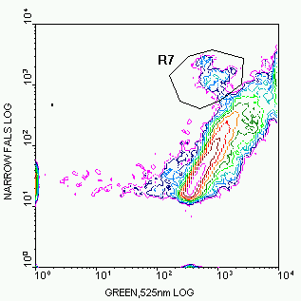 | b: ungated events 180 min  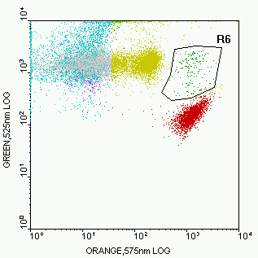
c: gated DNA⁺ or spores (R7), 45 min  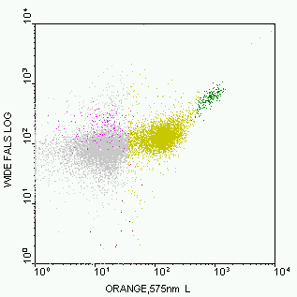 | d: gated DNA positive events, 45 min  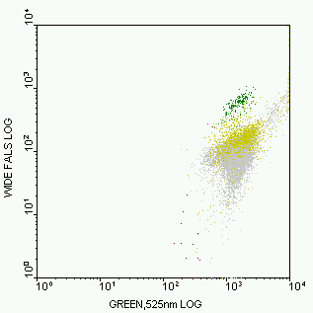
e: gated DNA positive events, 180 min  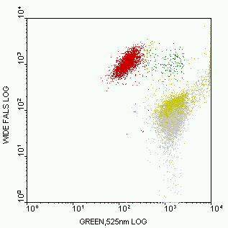 | f: gated DNA positive events, 330 min  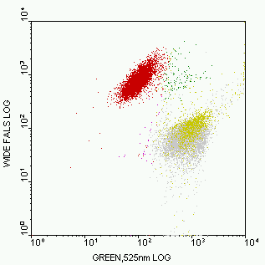
Figure 23
Three colour fluorescence of germinating Bacillus cereus T spores stained simultaneously with BOX, EB and PI (BEP): Picture (a) shows an ungated dot plot of orange (x-axis) versus green fluorescence (y-axis) with the same colour gates as in Figure 21 and Figure 22. Thus the same classification applies. In addition, some events are highlighted in pink and in dark green. The dark green represents the cells with high EB fluorescence that show an increased Wide FALS signal as indicated in pictures (b) to (e). Pictures (c) to (e) show that the bacteria highlighted in red (polarised but not pumping EB) also have increased Wide FALS. The pink events are non-germinated spores that are best separated in an image of green fluorescence versus Narrow FALS of the events negative for the DNA stains (picture (a) region R7). They even form two clusters, mainly based on their forward scatter signal.

The culture shock; recovery of injured Salmonella typhimurium
BEP staining of heatinjured Salmonella typhimurium gives the same cluster distribution as in Figure 22. Prolonged heat treatment causes increased loss of pump activity and increase in deenergized, depolarised and permeabilised cells (Figure 24). The original hope that the pumping cells could grow on high salt whilst the non-pumping cells would also grow on normal agar and the depolarised cells would require liquid culture for recovery was squashed by the fact that non of the cells grew when sorted onto agar plates. As the same cells could be plated out manually it emerged that sorting 3nl of buffer per cell caused an osmotic stress leading to the growth discrepancies. The fact that also only a few of the pumping cells recovered in when sorted into liquid broth lead to the argument that the cells died of culture shock. The recovery discrepancies emerging from the comparison of different preenrichment broth by MPN methods Figure 26 (Stephens et al. 1997) supported the argument. The recovery differences in excess of three log explains how comparison of single cell analysis to culture can create apparently ‘viable but non-culturable’ cells and seriously hampers any correlation between functional staining and cell growth.
Oxidative stress was identified as a major component of the culture shock. The beneficial role of catalase and other peroxide scavengers has been demonstrated by amongst others by Humphrey (Humphrey, 1988). From the incomplete protection against peroxide achieved by the addition of extracellular peroxide scavengers, he already suggested its endogenous production by the bacteria themselves. Experiments on models for reperfusion injury by Yurkow and McKenzie (Yurkow and McKenzie, 1993) demonstrated the lethal burst of oxygen radicals in yeast when exposed to oxygen following anaerobe culture. Observations from our own recovery experiments of injured cells in aerobic and anaerobic conditions lead to the theory of intrinsic and extrinsic oxidative damage, culminating in the development of the SPRINT medium [Oxoid, Basingstoke, UK]. This preenrichment medium consists of a buffered peptone water produced to contain a minimum of oxidative species. It is supplemented with a preparation of bacterial membranes [Oxoid, Basingstoke, UK] in order to remove oxygen to generate anaerobic growth conditions and to suppress toxic oxygen species generated under growth conditions. With more than 2 log increase in recovery of heatinjured cells in MPN plating experiments (Figure 25), the medium outperformed all the other batches tested.

Figure 24
Effect of heat injury on the physiological states of Salmonella typhimurium: Heart infusion broth was innocculated with an overnight culture of Salmonella and grown in a shaking waterbath to an OD of 0.3 at 600nm. Bacteria were heat injured at 51.5°C for different length of time and diluted 200µ1 diluted in 9ml of buffered peptone water at room temperature. Cells were allowed to equilibriate for more than 30 minutes before they were stained with EB/PI (5 µg•ml⁻¹) and BOX (0.5 µg•ml⁻¹) for 15 minutes and measured in the flow cytometer.

Figure 25
Recovery kinetics of injured S.typhimurium (15min 51.5°C) obtained by OD measurement of MPN dilutions in the Bioscreen. Recovery in SPRINT recovery medium shows more than 2 log increase in recovery compared to most typical buffered peptone water (BPW) down to single cell level. The true variation of lag times can only be measured from the recovery of single cells as it otherwise depends on the fastest recovering cell in the well.

Figure 26
Variation in the recovery of Salmonella typhimurium after 15minute 51.5°C heatinjury in different commercial preenrichment media under aerobic growth conditions using most probable number technique. The most typical result represents the average recovery of 20 other batches with very similar performance.
Sorting of injured Salmonella into BPW and SPRINT medium was performed in the hope to achieve better correlation to the fluorescent stains and to see which population suffers most from the growth related oxidative injury. As can be seen from Figure 27 and Figure 28, the more intense the damage the more improvement is gained by recovery in SPRINT medium. With a 330 fold increase in recovery (90min. injury), the cells with high respiratory activity as indicated by their high proton motive force driving the extrusion pumps benefit most from the oxidative protection. Deenergized and depolarised cells show a 33 and 19 fold improvement. This supports the assumption that injured cells with high metabolic activity cause a higher degree of intrinsic oxidative damage than cells that have to re-establish their respiratory system.

Figure 27
Recovery of Salmonella injured for 30, 40 and 60 minutes at 51.5°C and sorted into 96 well plates with BPW and SPRINT medium. To cope with low levels of recovery, 100, 10 and 1 cell was sorted for equal number of wells for each cluster and numbers of life cells were estimated as for most probable number dilutions.

Figure 28
Improvement of recovery in comlpetely reduced medium: At short injury times the improvement for all subpopulation is about 5 fold. With increased injury the benefit increases, most markedky with the pumping cells from 11% to 330%
There are two remaining discrepancies between the functional assessment and the cell recovery. The first one is the recovery of PI positive cells. As already mentioned in the section on membrane integrity measurements, pore formation can be caused temporarily by means of deliberate injury. The time it takes to seal those pores is not known, and the fact that the cells in our examples came from exponential growing cultures suggests that some of them could still have electron transport chains in their membrane makes it more likely that the cells might be capable of repair. The use of exponentially growing cells also increases the likelihood of ‘doublets’, e.g. two cells that are not yet completely separated with one permeabilised and one pumping cell. Both possibilities agree with the finding of increased benefit of the anaerobe recovery.
The second discrepancy lies in the proportion of cells that show metabolic function but still do not recover, even under protection from oxidisation. There is still a remaining element of osmotic stress that could be reduced, but the most likely reason for the discrepancy is the irreversible DNA damage already caused by the heat treatment. Whilst it might be difficult if not impossible to detect the presence of very few strand breaks, it might be easier to test both, recovery and staining methods on injury processes less likely to inflict such damage.

Bacterial differentiation: Antibody staining of ‘environmental’ samples.

Classical differentiation methods
Apart from growth on selective media, classical differentiation is primarily based on macroscopic information such as colony form, shape and smell and microscopic appearance such as morphology, mobility and gram staining. Any further differentiation is based on functional metabolism, of which the API classification system for Bio-Merieux is the most widely used system.
Certain aspects of biochemical differentiation can also be achieved on a single cell level. For some enzymes or pathways one can buy fluorescent substrates off the shelf (Haugland, 1992), as for example for beta-galactosidase which is commonly used in molecular biology as a marker gene (Srienc et al. 1986; Russo-Marie et al. 1993; Chung et al. 1995). As some of the colourimetric reactions do not take place inside the cell, but in the media, the use of gel-microdroplets has been suggested (Nir et al. 1990; Weaver, 1990). A more straight forward approach is monitoring growth or membrane potential / integrity in selective conditions, either by nutrients (Shapiro, 1990) or by antibiotic susceptibility. In clinical terms, the latter may be a differentiation far more important than perhaps the identification of species.
Gram staining can also be performed in a flow cytometer, either by fluorescent labelled lectin probes (Sizemore et al. 1990; Haugland, 1996) or by differential uptake of lipophilic probes before and after EDTA treatment (Shapiro, 1990).

Differentiation by nucleic acid probes
Bacteria can also be differentiated by their nucleic acid. The first approach has been taken by Van Dilla (Van Dilla et al. 1983), using differences in the A-T, G-C ratio of Staphylococcus aureus, Escherichia coli and Pseudomonas aeruginosa, stained with two DNA fluorochromes with preferred binding to either of the base-pairs. DNA measurements combined with light scatter allow separation of different sized micro-organisms in some cases (Allman et al. 1992; Allman et al. 1993) and it can be expected that the base pair specific stains could improve on that differentiation. A very specific labelling can be achieved using oligonucleotide probes, resembling complementary sequences to cell specific nucleic acid. Some of the nucleotides were originally labelled radioactively, but later either with haptens or direct with fluorochromes for visual detection. Genetic probes do not deliver sufficient signal for single cell labelling without employing primed fluorescent in situ hybridisation (Fischer et al. 1994) as there are usually only one to four copies per cell. The high copy number of ribosomal RNA and their preserved structure does allow direct detection and has proven useful for bacterial identification (Giovannoni et al. 1988; DeLong et al. 1989; Amann et al. 1990a; Amann et al. 1990b; Wagner et al. 1993) even simultaneous labelling with different probes with separate fluorochromes (Herrmann et al. 1997). As the ribosomal copy number depends on the metabolic activity of the bacteria (Herrmann et al. 1997), metabolic inactive and dead cells can escape the analysis leading to discrepancies between detection by DNA staining and detection rRNA (Hicks et al. 1992; Manz et al. 1993; Poulsen et al. 1993; Simon et al. 1995; Ramsing et al. 1996).
The biggest advantage of the rRNA probe is the possibility for computer aided design of the probe based on sequence information even without the prior isolation of a species and the possibility to generate probe for example with pan species or kingdom specificity, but their suitability for single cell detection has always to be tested as probe access does not only depend on the degree of cell permeabilisation but also the degree of higher order structure or denaturation (Frischer et al. 1996).

Identification by immunological methods
Cell differentiation by antigen-antibody recognition is the major application of FCM in immunology, where white blood cells are identified by functional epitopes via fluorescent labelled antibodies. Perhaps because the antibody recognition has proven quite successful in the evolution of the immune system, it is the most frequently used bio-recognition assay these days. There are also ever increasing numbers of antibody based ‘rapid tests’ in microbiology like the latex agglutination or the Clearview tests from Oxoid Basingstoke UK, used for culture confirmation or direct testing from for clinical samples. Despite their widespread use in bulk assays and even fluorescent microscopy, there is only a limited amount of literature about bacterial differentiation by antibodies in flow cytometry. A lot of the early publications suffered from poor cluster separation of the antibody labelled event from the background, but Sahar et al (Sahar et al. 1983) already demonstrated the advantage of counterstaining with ethidium bromide to discriminate bacteria from other particles. Others successfully used propidium iodide for that purpose (Tyndall et al. 1985; Donnelly and Baigent, 1986; Völsch et al. 1990). Such counterstaining is not always required, in particular when handling cultured cells which give rise to stronger light scatter signals. Thus in turn they can be used to assay antibodies in serum and the vaccination efficacy in men (Sachsenmeier et al. 1992; Callister et al. 1994; Lim et al. 1994; Callister et al. 1996; Creson et al. 1996; Padilla et al. 1996). Enhanced differentiation by multicolour antibody fluorescence has been demonstrated using separate fluorochromes for two antibodies (McClelland and Pinder, 1994) and four antibodies (Hutter, 1992) simultaneously with a single wavelength excitation. More recent studies by image and flow cytometry have even used combinations of immunofluorescence, rRNA probes (Li et al. 1997) and total DNA labelling (Assmus et al. 1997; Wallner et al. 1997).
The major advantage of differentiation by antibody compared to r-RNA probes is the possibility of simultaneous detection of membrane integrity or other information on viability as the cells do not need to be permeabilised and can be analysed in their native state. Drawbacks are the requirement for prior isolation and immunisation and potential variations in antigen presentation (Vickers et al. 1990; Lutton et al. 1991)
Dental plaque was one of the populations under investigation in this study. Immunofluorescent analysis by microscopy goes back to the mid 60’s (Jablon and Zinner, 1966; Duany et al. 1970; Grenier et al. 1973; Jablon et al. 1974). Flow cytometric analysis was attempted by Barnett et al (Barnett et al. 1984) and Obernesser et al (Obernesser et al. 1990) using polyclonal antisera. Both found good correlation between species detection in mixtures and FCM results, reasonable cluster separation, but incomplete labelling even of pure cultures and inconsistent bacterial detection by the instrumentation. Another immunofluorescent approach was the enumeration of dental bacteria in a 96 well plate assay by bulk measurement (Anderson et al. 1990; Wolff et al. 1991; Wolff et al. 1992). The most successful approach was made by Kamiya et al (Kamiya et al. 1994) who established a detection limit of 10^{2•}ml⁻¹ species specific bacteria by FCM.
Whilst ribosomal probes are said to suffer from problems with ribosomal copy numbers and probe access, the major drawback of antibodies is the variability of antigen expression highlighted quite frequently in the literature. Bowden et al (Bowden et al. 1995) even show bimodal intensity distributions amongst the antibody positive populations in their experiments. Unfortunately like most other authors they looked only at the histograms of the antibody fluorescence. The lack of counterstaining techniques or other methods of backgating to check for clustering in independent parameters invalidates a lot of the flow cytometric data. Without this discrimination it is not certain whether the fluorescent or non-fluorescent events are bacteria or not and published data have to be looked at very carefully.
The combination of membrane integrity measurement and immunofluorescence gave good differentiation of the plaque samples as verified by the sorting experiments. With the limitations of the viability stains in mind, it might as well be the most sensible combination currently possible for single laser excitation. As the information of membrane integrity prior to a fixation step can be preserved, similar studies should be performed with nucleic acid probes.

The next step to further improve the link between the bacterial detection, differentiation, their membrane integrity and their potential to grow is clearly the measurement of DNA damage. The methods and concepts described here using direct detection of single bacteria by cytometric techniques represent already a significant improvement in analysis and understanding of bacterial physiology compared to the growth dependent analysis methods.

Sample preparation for counting intact and permeabilised antibody labelled cells in 24 hour dental plaque:

- Plaque samples were obtained by scraping the smooth surface or the gingival margin of the upper incisors using a wooden applicator stick. Samples were dissolved in 2ml Dulbecco's phosphate buffered saline (DBS) and sonicated as described above for 2 minutes at 2µm amplitude and spiked with reference beads for counting.
- 5*10⁶ Bacteria were loaded into the well of a 96 well filter plate 0.2µm polycarbonate (Porvair filtronics, Sheperton, UK) and washed twice with 200µl DBS_{ABOT}(0.1%azide; 0.5%BSA; 0.5% ovalbumin; 0.05% Tween 20) by sucking the liquid through the plate.
- 200µl of antibody supernatant or 200µl DBS_{ABOT} containing 1µg purified antibody was added and incubated for 30 min at 25°C followed by two more washing steps in DBSat.
- Cells were resuspended in 200µl DBS_{ABOT} containing 1µg rabbit-anti mouse*FITC antibody, incubated for 30min 25°C and washed twice in DBS_{AT}.
- After final resuspension in 200µl DBS_{AT} containing 5-10µg×ml⁻¹ EB and PI cells were transferred into 600µl tubes for measurement.
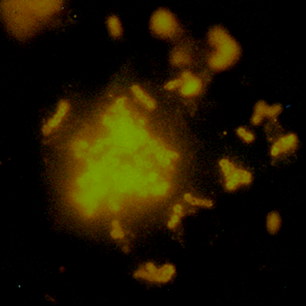
Figure 29
Ex vivo staining of fresh dental plaque grown on hydroxyapatite disks carried in the cheeks of volunteers for six hours: Bacteria were labelled for 5 minutes with 50 µl 4718 (mouse anti S.sanguis) at 25 µg·ml⁻¹ in the presence of saliva, rinsed in DBS and detected with PE conjugated goat-anti-rabbit (F(ab)₂) (b).

(a) primary detection and enumeration of intact and permeabilised bacteria
DNA negative debris
PI positive
EB negative;
permeabilized bacteria
EB positive
PI negative;
intact bacteria
0.66 µm yellow-green fluorescent reference beads

(b) antibody fluorescence of permeabilized bacteria | (c) antibody fluorescence of intact bacteria
(d) Intact and antibody-negative sort  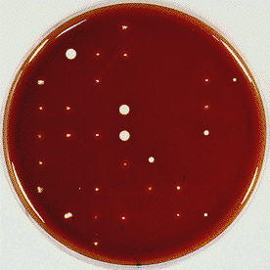 | (e) Intact and antibody-positive sort  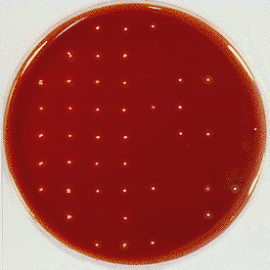
Figure 30
Antibody based analysis of dental plaque and it’s verification by cell sorting: Dental plaque was collected in DBS, spiked with reference beads, sonicated and labelled with antibody anti S.sanguis 4715 followed by rabbit-anti mouse*FITC F(ab)₂. Cells were briefly sonicated after staining to minimise the risk of aggregation. Cells were sorted based on membrane integrity and absence or presence of antibody label. Selected colonies were identified by API based on morphology and haemolytic capacity. 99.4% of the antibody positive cells were correctly identified, 3.6% appeared false negative, most likely due to the sonication of the antibody labelled cells

Bibliography
- Ackermann, J.U., Müller, S., Lösche, A., Bley, T. and Babel, W. (1995) Methylobacterium rhodesianum cells tend to double the DNA content under growth limitations and accumulate PHB. Journal Of Biotechnology 39, 9-20.
- Allman, R., Hann, A.C., Manchee, R. and Lloyd, D. (1992) Characterization of bacteria by multiparameter flow cytometry. J. Appl. Bacteriol. 73, 438-444.
- Allman, R., Manchee, R. and Lloyd, D. (1993) Flow cytometric analysis of heterogeneous bacterial populations. In: Lloyd, D. (Ed.) Flow Cytometry in Microbiology, pp. 27-47. London: Springer]
- Amann, R.I., Binder, B.J., Olson, R.J., Chisholm, S.W., Devereux, R. and Stahl, D.A. (1990a) Combination of 16S rRNA-targeted oligonucleotide probes with flow cytometry for analyzing mixed microbial populations. Applied And Environmental Microbiology 56, 1919-1925.
- Amann, R.I., Krumholz, L. and Stahl, D.A. (1990b) Fluorescent-oligonucleotide probing of whole cells for determinative, phylogenetic, and environmental studies in microbiology. J. Bacteriol. 172, 762-770.
- Anderson, L., Wolff, L.F., Sandberg, G.P. and Shelburne, C.E. (1990) Reproducibility of particle concentration fluorescent immunoassay for detecting plaque bacteria. Journal Of Dental Research 69, 354(Abstract)
- Assmus, B., Schloter, M., Kirchhof, G., Hutzler, P. and Hartmann, A. (1997) Improved in situ tracking of rhizosphere bacteria using dual staining with fluorescence-labeled antibodies and rRNA- targeted oligonucleotides. Microbial Ecology 33, BP 32-40.
- Bailey, J.E., Fazel-Madjlessi, J., McQuitty, D.N., Lee, Y.N., Allred, J.C. and Oro, J.A. (1977) Characterization of bacterial growth by means of flow microfluorometry. Science 198, 1175-1176.
- Barnes, E.M. (1956) Tetrazolium reduction as a means of differentiating Streptococcus faecalis from Streptococcus faecium. J. gen. Mirobiol. 14, 57-68.
- Barnett, J.M., Cuchens, M.A. and Buchanan, W. (1984) Automated immunofluorescent speciation of oral bacteria using flow cytometry. J. Dent. Res. 63, 1040-1042.
- Bovill, R.A., Shallcross, J.A. and Mackey, B.M. (1994) Comparison of the fluorescent redox dye 5-cyano-2,3-ditolyltetrazolium chloride with p-iodonitrotetrazolium violet to detect metabolic activity in heat-stressed Listeria monocytogenes cells. J. Appl. Bacteriol. 77, 353-358.
- Bowden, R.A., Cloeckaert, A., Zygmunt, M.S., Bernard, S. and Dubray, G. (1995) Surface exposure of outer membrane protein and lipopolysaccharide epitopes in Brucella species studied by enzyme-linked immunosorbent assay and flow cytometry. Infect. Immun. 63, 3945-3952.
- Boye, E. and Steen, H.B. (1993) The physical and biological basis for flow cytometry of Escherichia coli. In: Lloyd, D. (Ed.) Flow Cytometry in Microbiology, pp. 13-25. London: SpringerVerlag]
- Breeuwer, P., Drocourt, J.L., Bunschoten, N., Zwietering, M.H., Rombouts, F.M. and Abee, T. (1995) Characterization of uptake and hydrolysis of fluorescein diacetate and carboxyfluorescein diacetate by intracellular esterases in Saccharomyces cerevisiae, which result in accumulation of fluorescent product. Applied And Environmental Microbiology 61, 1614-1619.
- Buller, G. and Godfrey, B., (2005) Correlation of cyanine dye permeability with annexin V staining on apoptotic cells by fl ow cytometry http://probes.invitrogen.com/media/publications/529.pdf
- Callister, S.M., Jobe, D.A., Schell, R.F., Pavia, C.S. and Lovrich, S.D. (1996) Sensitivity and specificity of the borreliacidal-antibody test during early Lyme disease: a "gold standard"? Clin. Diagn. Lab. Immunol. 3, 399-402.
- Callister, S.M., Schell, R.F., Lim, L.C., Jobe, D.A., Case, K.L., Bryant, G.L. and Molling, P.E. (1994) Detection of borreliacidal antibodies by flow cytometry. An accurate, highly specific serodiagnostic test for Lyme disease. Arch. Intern. Med. 154, 1625-1632.
- Chung, J.D., Conner, S. and Stephanopoulos, G. (1995) Flow cytometric study of differentiating cultures of Bacillus subtilis. Cytometry 20, 324-333.
- Creson, J.R., Lim, L.C., Glowacki, N.J., Callister, S.M. and Schell, R.F. (1996) Detection of anti-Borrelia burgdorferi antibody responses with the borreliacidal antibody test, indirect fluorescent-antibody assay performed by flow cytometry, and western immunoblotting. Clin. Diagn. Lab. Immunol. 3, 184-190.
- Davey, H.M., Davey, C.L. and Kell, D.B. (1993) On the Determination of the Size of Microbial Cells Using Flow Cytometry. In: Lloyd, D. (Ed.) Flow Cytometry in Microbiology, pp. 49-65. London: Springer]
- DeLong, E.F., Wickham, G.S. and Pace, N.R. (1989) Phylogenetic stains: ribosomal RNA-based probes for the identification of single cells. Science 243, 1360-1363.
- Diaper, J.P. and Edwards, C. (1994) The use of fluorogenic esters to detect viable bacteria by flow-cytometry. Journal Of Applied Bacteriology 77, 221-228.
- Dien, B.S., Peterson, M.S. and Srienc, F. (1994) Cell-cycle analysis of Saccharomyces cerevisiae. Methods Cell Biol. 42 Pt B, 457-475.
- Donnelly, C.W. and Baigent, G.J. (1986) Method for flow cytometric detection of Listeria monocytogenes in milk. Applied And Environmental Microbiology 52, 689-695.
- Duany, L.F., Zinner, D.D. and Jablon, J.M. (1970) Identification of types of potentially cariogenic streptococci on human tooth surfaces by the fluorescent antibody technique. J. Dent. Res. 49, Suppl:1527-9.
- Durodie, J., Coleman, K. and Wilkinson, M.J. (1993) Characterisation of bacterial cell size and ploidy using flow cytometry and image analysis. In: Lloyd, D. (Ed.) Flow Cytometry in Microbiology, pp. 95-109. London: Springer Verlag]
- Edwards, C. (1996) Assessment of viability of bacteria by flow cytometry. In: Al-Rubeai, M. and Emery, A.N. (Eds.) Flow cytometry in applications in cell culture, pp. 291-310. New York: Marcle Dekker Inc.]
- Fischer, H., Hindkjaer, J., Pedersen, S., Koch, J., Brandt, C. and Kolvraa, S. (1994) Primed in situ labeling (PRINS) and fluorescence in situ hybridization (FISH). Methods Cell Biol. 42, 71-93.
- Frischer, M.E., Floriani, P.J. and Nierzwicki-Bauer, S.A. (1996) Differential sensitivity of 16S rRNA targeted oligonucleotide probes used for fluorescence in situ hybridization is a result of ribosomal higher order structure. Canadian Journal Of Microbiology 42, 1061-1071.
- Gant, V.A., Warnes, G., Phillips, I. and Savidge, G.F. (1993) The application of flow cytometry to the study of bacterial responses to antibiotics. J. Med. Microbiol. 39, 147-154.
- Giovannoni, S.J., DeLong, E.F., Olsen, G.J. and Pace, N.R. (1988) Phylogenetic group-specific oligodeoxynucleotide probes for identification of single microbial cells. J. Bacteriol. 170, 720-726.
- Grenier, E.M., Eveland, W.C. and Loesche, W.J. (1973) Identification of Streptococcus mutans serotypes in dental plaque by fluorescent antibody techniques. Arch. Oral Biol. 18, 707-715.
- Haugland, R. (1992) Handbook of fluorescent probes and research chemicals, 5th edn. Eugene: Molecular Probes.
- Haugland, R. (1996) Handbook of fluorescent probes and research chemicals, 6th edn. Eugene: Molecular Probes.
- Herrmann, C., Losche, A., Muller, S., Bley, T. and Babel, W. (1997) Flow cytometric discrimination between acinetobacter calcoaceticus 69-v and alcaligenes eutrophus jmp134 by fluorescently labelled rRNA-targeted oligonucleotide probes and DNA staining. Acta Biotechnologica 17, 19-38.
- Hicks, R.E., Amann, R.I. and Stahl, D.A. (1992) Dual staining of natural bacterioplankton with 4',6-diamidino-2-phenylindole and fluorescent oligonucleotide probes targeting kingdom-level 16S rRNA sequences. Applied And Environmental Microbiology 58, 2158-2163.
- Huang, C.T., Yu, F.P., McFeters, G.A. and Stewart, P.S. (1995) Nonuniform spatial patterns of respiratory activity within biofilms during disinfection. Appl. Environ. Microbiol. 61, 2252-2256.
- Humphrey, T.J. (1988) Peroxide sensitivity and catalase activity in Campylobacter jejuni after injury and during recovery. Journal Of Applied Bacteriology 64, 337-343.
- Hutter, K.J. (1974) Untersuchungen über die DNS-, RNS- und Proteinsynthese von Hefezellen der Gattung Sacharomyces mit Hilfe neuer fluorometrischer Methoden. 19/FB13, Berlin.
- Hutter, K.J. (1992) Simultaneous multiparametric flow cytometric analysis of different species of microorganisms. Monatsschrift Fur Brauwissenschaft 45, 280-284.
- Hutter, K.J. and Oldiges, H. (1980) Alterations of proliferating microorganisms by flow cytometric measurements after heavy metal intoxication. Ecotoxicol. Environ. Saf. 4, 57-76.
- Idziorek T, Estaquier J, De Bels F, Ameisen JC., (1995) YOPRO-1 permits cytofluorometric analysis of programmed cell death (apoptosis) without interfering with cell viability., J Immunol Methods 185, 249-258
- Jablon, J.M. and Zinner, D.D. (1966) Differentiation of cariogenic streptococci by fluorescent antibody. J. Bacteriol. 92, 1590-1596.
- Jablon, J.M., Ferrer, T. and Zinner, D.D. (1974) Quantitation of Streptococcus mutans by the membrane filter fluorescent antibody technique. Arch. Oral Biol. 19, 929-934.
- Jacobsen, C.N., Rasmussen, J. and Jakobsen, M. (1997) Viability staining and flow cytometric detection of listeria monocytogenes. Journal Of Microbiological Methods 28, 35-43.
- Jepras, R.I., Carter, J., Pearson, S.C., Paul, F.E. and Wilkinson, M.J. (1995) Development of a robust flow cytometric assay for determining numbers of viable bacteria. Applied And Environmental Microbiology 61, 2696-2701.
- Jepras, R.I., Paul, F.E., Pearson, S.C. and Wilkinson, M.J. (1997) Rapid assessment of antibiotic effects on Escherichia coli by bis-(1,3-dibutylbarbituric acid) trimethine oxonol and flow cytometry. Antimicrobial Agents And Chemotherapy 41, 2001-2005.
- Jernaes, M.W. and Steen, H.B. (1994) Staining of Escherichia coli for Flow Cytometry: Influx and Efflux of Ethidium Bromide. Cytometry 17, 302-309.
- Kamiya, I., Okuda, K. and Hara, K. (1994) Flow-cytometric identification and detection of Porphyromonas gingivalis by a LPS specific monoclonal antibody. J. Periodontol. 65, 309-315.
- Kaprelyants, A.S. and Kell, D.B. (1992) Rapid assessment of bacterial viability and vitality by rhodamine 123 and flow cytometry. Journal Of Applied Bacteriology 72, BP 410-422.
- Kaprelyants, A.S. and Kell, D.B. (1993a) The use of 5-cyano-2,3-ditolyl tetrazolium chloride and flow-cytometry for the visualization of respiratory activity in individual cells of micrococcus-luteus. Journal Of Microbiological Methods 17, 115-122.
- Kaprelyants, A.S. and Kell, D.B. (1993b) Dormancy in stationary-phase cultures of Micrococcus-luteus - flow cytometric analysis of starvation and resuscitation. Applied And Environmental Microbiology 59, 3187-3196.
- Krishan, A. (1987) Effect of drug efflux blockers on vital staining of cellular DNA with Hoechst 33342. Cytometry 8, 642-645.
- Lambert, B. and Le, P., JB (1984) Effect of mutation, electric membrane potential, and metabolic inhibitors on the accessibility of nucleic acids to ethidium bromide in Escherichia coli cells. Biochemistry 23, 166-176.
- Langsrud, S. and Sundheim, G. (1996) Flow cytometry for rapid assessment of viability after exposure to a quaternary ammonium compound. Journal Of Applied Bacteriology 81, 411-418.
- Li, X., De, B., SH and Ward, L.J. (1997) Improved microscopic identification of Clavibacter michiganensis subsp. sepedonicus cells by combining in situ hybridization with immunofluorescence. Lett. Appl. Microbiol. 24, 431-434.
- Lim, L.C., Liu, Y.F., Schell, K., Lovrich, S.D., Callister, S.M. and Schell, R.F. (1994) Detection of borreliacidal antibody by using acridine orange and flow cytometry. Clin. Diagn. Lab. Immunol. 1, 44-50.
- López-Amorós, R., Comas, J. and Vives-Rego, J. (1995) Flow cytometric assessment of Escherichia-coli and Salmonella-typhimurium starvation-survival in seawater using rhodamine- 123, propidium iodide, and oxonol. Applied And Environmental Microbiology 61, 2521-2526.
- Lutton, D.A., Patrick, S., Crockard, A.D., Stewart, L.D., Larkin, M.J., Dermott, E. and McNeill, T.A. (1991) Flow cytometric analysis of within-strain variation in polysaccharide expression by Bacteroides fragilis by use of murine monoclonal antibodies. J. Med. Microbiol. 35, 229-237.
- Manz, W., Szewzyk, U., Ericsson, P., Amann, R., Schleifer, K.H. and Stenström, T.A. (1993) In situ identification of bacteria in drinking water and adjoining biofilms by hybridization with 16S and 23S rRNA-directed fluorescent oligonucleotide probes. Applied And Environmental Microbiology 59, 2293-2298.
- Matsunaga, T., Okochi, M. and Nakasonon, S. (1995) Direct count of bacteria using fluorescent dyes: application to assessment of electrochemcial disinfection. Anal. Chem. 67, 4487-4490.
- McClelland, R.G. and Pinder, A.C. (1994) Detection of low-levels of specific Salmonella species by fluorescent-antibodies and flow-cytometry. Journal Of Applied Bacteriology 77, 440-447.
- Midgley, M. (1986) The phosphonium ion efflux system of Escherichia coli: relationship to the ethidium efflux system and energetic studies. J. Gen. Microbiol. 132 ( Pt 11), 3187-3193.
- Midgley, M. (1987) An efflux system for cationic dyes and related compounds in E.coli. Microbiol. Sci. 4, 125-128.
- Midgley, M., Iscandar, N.S., Parish, M. and Dawes, E.A. (1986) A fluorescent-probe for a phosphonium ion efflux system in bacteria. FEMS Microbiology Letters 34, 187-190.
- Miyauchi, S., Komatsubara, M. and Kamo, N. (1992) In archaebacteria, there is a doxorubicin efflux pump similar to mammalian P-glycoprotein. Biochim. Biophys. Acta 1110, 144-150.
- Molenaar, D., Bolhuis, H., Abee, T., Poolman, B. and Konings, W.N. (1992) The efflux of a fluorescent probe is catalyzed by an ATP-driven extrusion system in Lactococcus lactis. J. Bacteriol. 174, 3118-3124.
- Monfort, P. and Baleux, B. (1996) Cell cycle characteristics and changes in membrane potential during growth of escherichia coli as determined by a cyanine fluorescent dye and flow cytometry. Journal Of Microbiological Methods 25, 79-86.
- Müller, S., Loffhagen, N., Bley, T. and Babel, W. (1996) Membrane-potential-related fluorescence intensity indicates bacterial injury. Microbiological Research 151, 127-131.
- Muller, S., Losche, A., Bley, T. and Scheper, T. (1995) A flow cytometric approach for characterization and differentiation of bacteria during microbial processes. Applied Microbiology And Biotechnology 43, 93-101.
- Nebe-von Caron, G. and Badley, R.A. (1995) Viability assessment of bacteria in mixed populations using flow-cytometry. Journal Of Microscopy-Oxford 179, 55-66.
- Nebe-von Caron, G. and Badley, R.A. (1995) Viability assessment of bacteria in mixed populations using flow-cytometry. Journal Of Microscopy-Oxford 179, 55-66.
- Nebe-von Caron, G., Badley, R.A. and Powell, J.R. (1994) Identification and viability assessment of bacterial species in natural samples by flow cytometry and sorting. Cytometry Supp.7, 37(Abstract)
- Novo D, Perlmutter NG, Hunt RH, Shapiro HM. (1999): Accurate flow cytometric membrane potential measurement in bacteria using diethyloxacarbocyanine and a ratiometric technique. Cytometry, 35:55-63
- Nir, R., Yisraeli, Y., Lamed, R. and Sahar, E. (1990) Flow cytometry sorting of viable bacteria and yeasts according to beta-galactosidase activity. Applied And Environmental Microbiology 56, 3861-3866.
- Nybroe, O. (1995) Assessment of metabolic-activity of single bacterial-cells - new developments in microcolony and dehydrogenase assays. FEMS Microbiology Ecology 17, 77-83.
- Obernesser, M.S., Socransky, S.S. and Stashenko, P. (1990) Limit of resolution of flow cytometry for the detection of selected bacterial species. Journal Of Dental Research 69, 1592-1598.
- Paau, A.S., Cowles, J.R. and Oro, J. (1977) Flow-microfluorometric analysis of Escherichia coli, Rhizobium meliloti, and Rhizobium japonicum at different stages of the growth cycle. Canadian Journal Of Microbiology 23, 1165-1169.
- Padilla, M.L., Callister, S.M., Schell, R.F., Bryant, G.L., Jobe, D.A., Lovrich, S.D., DuChateau, B.K. and Jensen, J.R. (1996) Characterization of the protective borreliacidal antibody response in humans and hamsters after vaccination with a Borrelia burgdorferi outer surface protein A vaccine. J. Infect. Dis. 174, 739-746.
- Poot, M. Nebe-von Caron, G. 1994. Stability of BacLight in aqueous solutions.
- Porter, J., Edwards, C. and Pickup, R.W. (1995) Rapid assessment of physiological status in Escherichia-coli using fluorescent-probes. J. Appl. Bacteriol. 79, 399-408.
- Porter, J., Pickup, R. and Edwards, C. (1997) Evaluation of flow cytometric methods for the detection and viability assessment of bacteria from soil. Soil Biology & Biochemistry 29, 91-100.
- Poulsen, L.K., Ballard, G. and Stahl, D.A. (1993) Use of rRNA fluorescence in situ hybridization for measuring the activity of single cells in young and established biofilms. Applied And Environmental Microbiology 59, 1354-1360.
- Ramsing, N.B., Fossing, H., Ferdelman, T.G., Andersen, F. and Thamdrup, B. (1996) Distribution of bacterial populations in a stratified fjord (Mariager Fjord, Denmark) quantified by in situ hybridization and related to chemical gradients in the water column. Applied And Environmental Microbiology 62, 1391-1404.
- Rodriguez, G.G., Phipps, D., Ishiguro, K. and Ridgway, H.F. (1992) Use of a fluorescent redox probe for direct visualization of actively respiring bacteria. Applied And Environmental Microbiology 58, 1801-1808.
- Russo-Marie, F., Roederer, M., Sager, B., Herzenberg, L.A. and Kaiser, D. (1993) Beta-galactosidase activity in single differentiating bacterial cells. Proc. Natl. Acad. Sci. U. S. A. 90, 8194-8198.
- Sachsenmeier, K.F., Schell, K., Morrissey, L.W., Pennell, D.R., West, R.M., Callister, S.M. and Schell, R.F. (1992) Detection of borreliacidal antibodies in hamsters by using flow cytometry. J. Clin. Microbiol. 30, 1457-1461.
- Sahar, E., Lamed, R. and Ofek, I. (1983) Rapid identification of Streptococcus pyogenes by flow cytometry. Eur. J. Clin. Microbiol. 2, 192-195.
- Schmid, I., Nicholson, J.K., Giorgi, J.V., Janossy, G., Kunkl, A., Lopez, P.A., Perfetto, S., Seamer, L.C. and Dean, P.N. (1997) Biosafety guidelines for sorting of unfixed cells. Cytometry 28, 99-117.
- Sgorbati, S., Barbesti, S., Citterio, S., Bestetti, G. and DeVecchi, R. (1996) Characterization of number, dna content, viability and cell size of bacteria from natural environments using DAPI/PI dual staining and flow cytometry. Minerva Biotecnologica 8, BP 9-15.
- Shapiro, H.M. (1988) Practical flow cytometry. Second edn. New York: Wiley Liss Inc.
- Shapiro, H.M. (1990) Flow cytometric aproaches to clinical microbiology. Labmedica 20-24.
- Shapiro, H.M. (1990a) Flow Cytometry in Laboratory Microbiology: New Directions. ASM News 56, 584-588.
- Shapiro, H.M. (1990b) Flow cytometric aproaches to clinical microbiology. Labmedica 20-24.
- Shapiro, H.M. (1995) Practical flow cytometry. Third edn. New York: Wiley Liss Inc.
- Shapiro HM, Nebe-Von-Caron G. (2004) Multiparameter flow cytometry of bacteria. Methods Mol Biol; 263:33-44
- Shi, L., Günther, S., Hübschmann, T., Wick, L.Y., Harms,H. and Müller ,S. (2007) Limits of propidium iodide as a cell viability indicator for environmental bacteria. Cytometry, online publication April 2007
- Simon, N., LeBot, N., Marie, D., Partensky, F. and Vaulot, D. (1995) Fluorescent in situ hybridization with rRNA-targeted oligonucleotide probes to identify small phytoplankton by flow cytometry. Applied And Environmental Microbiology 61, 2506-2513.
- Sizemore, R.K., Caldwell, J.J. and Kendrick, A.S. (1990) Alternate gram staining technique using a fluorescent lectin. Applied And Environmental Microbiology 56, 2245-2247.
- Smith, J.J. and McFeters, G.A. (1996) Effects of substrates and phosphate on int (2-(4-iodophenyl)3-(4-nitrophenyl)-5-phenyl tetrazolium chloride) and ctc (5- cyano-2,3-ditolyl tetrazolium chloride) reduction in escherichia coli. Journal Of Applied Bacteriology 80, 209-215.
- Srienc, F. and Dien, B.S. (1992) Kinetics of the cell cycle of Saccharomyces cerevisiae. Ann. N. Y. Acad. Sci. 665, 59-71.
- Srienc, F., Campbell, J.L. and Bailey, J.E. (1986) Flow cytometry analysis of recombinant Saccharomyces cerevisiae populations. Cytometry 7, 132-141.
- Steen, H.B., Boye, E., SKARSTAD, K., Bloom, B., Godal, T. and Mustafa, S. (1982) Applications of flow cytometry on bacteria: cell cycle kinetics, drug effects, and quantitation of antibody binding. Cytometry 2, 249-257.
- Stephens, P.J., Joynson, J.A., Davies, K.W., Holbrook, R., LappinScott, H.M. and Humphrey, T.J. (1997) The use of an automated growth analyser to measure recovery times of single heat-injured Salmonella cells. Journal Of Applied Microbiology 83, 445-455.
- Thom, S.M., Horobin, R.W., Seidler, E. and Barer, M.R. (1993) Factors affecting the selection and use of tetrazolium salts as cytochemical indicators of microbial viability and activity. Journal Of Applied Bacteriology 74, 433-443.
- Tyndall, R.L., Hand, R.E., Jr., Mann, R.C., Evans, C. and Jernigan, R. (1985) Application of flow cytometry to detection and characterization of Legionella spp. Applied And Environmental Microbiology 49, 852-857.
- Ullrich, S., Karrasch, B., Hoppe, H.G., Jeskulke, K. and Mehrens, M. (1996) Toxic effects on bacterial metabolism of the redox dye 5-cyano-2,3-ditolyl tetrazolium chloride. Applied And Environmental Microbiology 62, 4587-4593.
- Van Dilla, M.A., Langlois, R.G., Pinkel, D., Yajko, D. and Hadley, W.K. (1983) Bacterial characterization by flow cytometry. Science 220, 620-622.
- Vickers, R.M., Stout, J.E. and Yu, V.L. (1990) Failure of a diagnostic monoclonal immunofluorescent reagent to detect Legionella pneumophila in environmental samples. Applied And Environmental Microbiology 56, 2912-2914.
- Völsch, A., Nader, W.F., Geiss, H.K., Nebe, G. and Birr, C. (1990) Detection and analysis of two serotypes of ammonia-oxidizing bacteria in sewage plants by flow cytometry. Applied And Environmental Microbiology 56, 2430-2435.
- Wagner, M., Amann, R., Lemmer, H. and Schleifer, K.H. (1993) Probing activated sludge with oligonucleotides specific for proteobacteria: inadequacy of culture-dependent methods for describing microbial community structure. Applied And Environmental Microbiology 59, 1520-1525.
- Wallner, G., Steinmetz, I., Bitter-Suermann, I. and Amann, R. (1997) Combination of rRNA-targeted hybridization probes and immuno-probes for the identification of bacteria by flow cytometry. Syst. Appl. Microbiol. 19, 569-576.
- Walsh, S., LappinScott, H.M., Stockdale, H. and Herbert, B.N. (1995) An assessment of the metabolic activity of starved and vegetative bacteria using two redox dyes. Journal Of Microbiological Methods 24, 1-9.
- Weaver, J.C. Nebe-von Caron, G. 1990. Use of gel microdroplets for bacterial differentiation.
- Wold, S., SKARSTAD, K., Steen, H.B., Stokke, T. and Boye, E. (1994) The initiation mass for dna-replication in escherichia-coli k-12 is dependent on growth-rate. Embo Journal 13, 2097-2102.
- Wolff, L.F., Anderson, L., Sandberg, G.P., Aeppli, D.M. and Shelburne, C.E. (1991) Fluorescence immunoassay for detecting periodontal bacterial pathogens in plaque. J. Clin. Microbiol. 29, 1645-1651.
- Wolff, L.F., Anderson, L., Sandberg, G.P., Reither, L., Binsfeld, C.A., Corinaldesi, G. and Shelburne, C.E. (1992) Bacterial concentration fluorescence immunoassay (BCFIA) for the detection of periodontopathogens in plaque. J. Periodontol. 63, 1093-1101.
- Yu, F.P. and McFeters, G.A. (1994) Physiological responses of bacteria in biofilms to disinfection. Appl. Environ. Microbiol. 60, 2462-2466.
- Yurkow, E.J. and McKenzie, M.A. (1993) Characterization of hypoxia-dependent peroxide production in cultures of Saccharomyces cerevisiae using flow cytometry: a model for ischemic tissue destruction. Cytometry 14, 287-293.
- Zweifel, U.L. and Hagsröm, A. (1995) Total counts of marine bacteria include a large fraction of non-nucleoid-containing bacteria (ghosts). Applied And Environmental Microbiology 56, 2180-2185.

Quotation from a special edition of the Journal of ‘The Journal of Microbiological Methods’ published from the conference on 'Analysis of Microbial Cells at the Single Cell Level - Why, How, When?', organized by the Microbial Physiology Section of the European Federation of Biotechnology, the Federation of European Microbiological Societies (FEMS), the Societa Italiana di Microbiologia Generale e Biotechnologie Microbiche (SIMGBM), the Italian Group of Cytometry (GIC), and the Universities of Milan, and held in Como, Italy, March 25-27, 1999. The next meeting will take place Bad Schandau, Germany, 22–25 May 2008.
The journal was guest edited by

Lilia Alberghina
Danilo Porro
Howard Shapiro
Friedrich Srienc
Harald Steen

Although it was observation through the microscope that first made humans aware of the existence of the microbial world, the detection, identification, and, especially, chemical characterization of microorganisms have typically been accomplished by analysis of relatively large numbers of cells. Recent advances in microscopy, microspectrophotometry, and static and flow cytometry have made it possible to perform precise, sensitive, and specific analyses of individual microbial cells, with actual or potential benefit for almost every area of microbiology. The papers in this issue should provide a picture of the current state of the art.

The conference topic is introduced by Shapiro in 'Microbial Analysis at the Single-Cell Level: Tasks and Techniques'. In 'FT-IR Microspectroscopy for Microbiological Studies', Orsini et al. discuss spectroscopic characterization of metabolism in different areas of yeast microcolonies, while in 'Single-cell Analysis of Bacteria by Raman Microscopy: Spectral Information on the Chemical Composition of Cells and on the Heterogeneity in a Culture', Schuster et al. take micro spectrophotometric analysis to the level of single bacterial cells.

Introduced reporter genes such as that for the Aequorea green fluorescent protein (Gfp) have become increasingly important in microbiology, as in other fields of biology; Gordon et al., utilizing confocal and fluorescence microscopy, describe 'A Glucoamylase: GFP Gene Fusion to Study Protein Secretion by Individual Hyphae of Aspergillus niger', while De Wulf et al. report on 'Real-Time Flow Cytometric Quantification of GFP Expression and Gfp-Fluorescence Generation in Saccharomyces cerevisiae''. Analysis at the single cell level often provides several alternative methods for characterizing a microbial property; Porro et al., in 'Relating Growth Dynamics and Glucoamylase Excretion of Individual Saccharomyces cerevisiae Cells,' use flow cytometry and a fluorescent antibody against the product rather than a reporter gene.

Flow cytometry, which has for may years been indispensable for research in hematology, immunology, and oncology, among other fields, is now attracting the attention of more microbiologists. Steen, a pioneer in the field, provides both historical background and scientific rationale in 'Flow Cytometry of Bacteria: Glimpses from the Past with a View to the Future'. Porter and Pickup, in 'Nucleic Acid-based Fluorescent Probes in Microbial Ecology: Application of Flow Cytometry/ review methodology which allows characterization of microbial populations which may include nonculturable species, while Katsuragi et al., in 'Gel Microdroplet Technique Leaving Microorganisms Alive for Sorting by Flow Cytometry', describe a procedure which allows relatively destructive methods to be used as selection criteria for sorting. The ability of flow cytometry to provide direct, quantitative information about cellular physiologic processes is demonstrated by Natarajan and Srienc in 'Glucose Uptake Rates of Single E. coli. Cells Grown in Glucose-Limited Chemostat Culture'.

The power of cytometry is best realized by multiparameter analysis, in which combinations of fluorescent reagents are used to simultaneously characterize two or more cellular properties, e.g., bacterial membrane potential and membrane permeability. Nebe-von-Caron et al. provide a graphic illustration of the capabilities of this technique in the last paper in this issue, 'Analysis of Bacterial Function by Multi-Colour Fluorescence Flow Cytometry and Single Cell Sorting'.

Article links for this special issue (bound to disappear at some point)

Editorial: Microbial Analysis at the Single-Cell Level
L. Alberghina, D. Porro, H. Shapiro, F. Srienc, H. Steen; pp.1-2 (http://www.elsevier.com/homepage/sah/mimet/speciss/1367.pdf)
Microbial Analysis at the Single-Cell Level: Tasks and Techniques
H. M. Shapiro; pp. 3-16 (http://www.elsevier.com/homepage/sah/mimet/speciss/1368.pdf)
FT-IR Microspectroscopy for Microbiological Studies
F.Orsini, D.Ami, A.M.Villa, G.Sala, M.G.Bellotti, S.M.Doglia; pp. 17-27 (http://www.elsevier.com/homepage/sah/mimet/speciss/1369.pdf)
Single-cell Analysis of Bacteria by Raman Microscopy: Spectral Information on the Chemical Composition of Cells and on the Heterogeneity in a Culture
K. C. Schuster, E. Urlaub, J. R. Gapes; pp. 29-38 (http://www.elsevier.com/homepage/sah/mimet/speciss/1370.pdf)
A Glucoamylase:GFP Gene Fusion to Study Protein Secretion by Individual Hyphae of Aspergillus niger
C.L. Gordon, D.B. Archer, D.J. Jeenes, J.H. Doonan, B. Wells, A.P.J. Trinci, G.D. Robson; pp. 39-48 (http://www.elsevier.com/homepage/sah/mimet/speciss/1371.pdf)
Relating Growth Dynamics and Glucoamylase Excretion of Individual Saccharomyces cerevisiae Cells
D. Porro, M. Venturini, L. Brambilla, L. Alberghina, M. Vanoni; pp. 49-55 (http://www.elsevier.com/homepage/sah/mimet/speciss/1372.pdf)
Real-Time Flow Cytometric Quantification of GFP Expression and Gfp-Fluorescence Generation in Saccharomyces cerevisiae
P. De Wulf, L. Brambilla, M.Vanoni, D. Porro, L. Alberghina; pp. 57-64 (http://www.elsevier.com/homepage/sah/mimet/speciss/1373.pdf)
Flow Cytometry of Bacteria: Glimpses from the Past with a View to the Future
H. B. Steen; pp. 65-74 (http://www.elsevier.com/homepage/sah/mimet/speciss/1374.pdf)
Nucleic Acid-based Fluorescent Probes in Microbial Ecology: Application of Flow Cytometry
J. Porter, R. W. Pickup; pp. 75-79 (http://www.elsevier.com/homepage/sah/mimet/speciss/1375.pdf)
Gel Microdroplet Technique Leaving Microorganisms Alive for Sorting by Flow Cytometry
T. Katsuragi, S. Tanaka, S. Nagahiro, Y. Tani; pp. 81-86 (http://www.elsevier.com/homepage/sah/mimet/speciss/1376.pdf)
Glucose Uptake Rates of Single E. coli Cells Grown in Glucose-LimitedChemostat Culture
A. Natarajan, F. Srienc; pp. 87-96 (http://www.elsevier.com/homepage/sah/mimet/speciss/1377.pdf)
Analysis of Bacterial Function by Multi-Colour Fluorescence Flow Cytometry and Single Cell Sorting
G. Nebe-von-Caron, P. J. Stephens, C. J. Hewitt, J. R. Powell, R. A. Badley; pp. 97-114 (http://www.elsevier.com/homepage/sah/mimet/speciss/1378.pdf)

Microbial Flow Cytometry in Biotechnology
by Dr. Susann Müller,
Helmholtz-Zentrum für Umweltforschung GmbH – UFZ
Department Umweltmikrobiologie
AG Flow Cytometry
Permoserstraße 15 / D-04318 Leipzig

Yeasts
Methods for characterizing the physiological conditions of microbial populations and in particular flow cytometry are fast becoming indispensable for monitoring biotechnical processes. The production of baker’s yeast and yeast cultivation for the brewing industry are good examples of the fact that process management carried out on the basis of cytometric measurement can make the processes concerned more efficient and reliable. These methods can be used to characterize the main intracellular processes affecting the quality and quantity of baker’s and brewer’s yeast. As well as the levels of DNA and storage lipids (neutral fats), these intracellular processes also include the content of membrane-bound 3ß-hydroxysterols – which in addition to initiating the cell cycle also have a protective function in the metabolism of the yeast cell via the condensation of the membrane’s phospholipids.
Owing to its structural properties, the polyene macrolid antibiotic nystatin coupled to FITC proved to be ideal for labeling membrane sterols both in yeast cells and in human and animal cell systems.
In contrast to other polyene antibiotics, nystatin has a higher bonding affinity to ergosterin. The covalent bonding of fluorescein isothiocynate to the mycosamine sugar of nystatin A1 was performed in order to boost the quantum efficiency of fluorescence labeling, as well as to excite this cell material in the visible range and thus be able to measure it.
Mechanism
Nystatin A1 acts from two sides on the membrane bilayer, with pores being formed vertical to the membrane bilayer. A nystatin molecule takes up half the width of this bilayer. The polar end with the carboxyl group and the mycosamine protrude from the bilayer, whereas the non-polar end is located with the hydroxyl group inside the membrane. A pore arises whose internal side is hydrophilic and whose external side facing the membrane lipids is hydrophobic. With a ten-fold excess of nystatin, between 0.5 and 2 ´ 109 conjugate molecules/yeast cells are incorporated, corresponding to a rate of between 1:1 and 1:4 (3ß-hydroxysterol/nystatin [determined for baker’s yeast]).
Literature:
- Müller, S., Schmidt, A. Flow cytometric determination of yeast sterol content. Acta Biotechnol. 9, 71–75 (1989).
- Müller, S., Lösche, A., Bley, Th. Flow-cytometric investigation of sterol content and proliferation activity of yeast. Acta Biotechnol. 12 (1992) 5, 365–375.
- Müller, S., Hutter, K.J., Bley, T., Petzold, L., Babel, W. Dynamics of yeast cell states during proliferation and non-proliferation periods in a brewing reactor monitored by multidimensional flow cytometry. Bioprocess Engineering, 17 (1997), 287–293.

Analysis of 3ß-hydroxysterols

Fixing the yeast cells
At least 60 min in 70% ice-cold ethanol (storability depending on strain: 2–6 months).
Producing the conjugate
- Dissolve 1mg FITC in 1ml carbonate/bicarbonate buffer (pH 9.5).
- Dissolve 3mg nystatin in 100µl dimethyl formamide (carefully warming it if necessary). Add 1ml carbonate/bicarbonate buffer (pH 9.5), whereupon the mixture turns cloudy again. It should be carefully warmed once more until the solution is clear.
- Add 100µl FITC (item 1) to the nystatin solution.
- The conjugate forms within 24 hours at 4°C in the dark.
Cleaning the conjugate
- Apply the conjugate mixture onto a Sephadex G15 column size: 10mm x 300 mm.
- Elute the washed conjugate in carbonate/bicarbonate buffer (pH 9.5) after about 45–60 min.
- Perform the equilibriation of the column by removing unbound nystatin and FITC (I+II) using NaCl/phosphate buffer (pH 7.2).
- The collected conjugate should then be calibrated on the spectrophotometer at a wavelength of 485nm and an extinction of 0.17. This concentration is sufficient to calibrate the staining balance (even for cells with a high sterol content).
Staining instructions
- Wash the fixed cells with carbonate/bicarbonate buffer (pH 9.5).
- Adjust the cells to 5 x 106 cells/ml in carbonate/bicarbonate buffer (pH 9.5).
- Centrifuge the cells and resuspend them in 1.5ml freshly prepared conjugate.
- Stain them overnight at 4°C in the dark.
- Immediately before measurement, centrifuge the cells and resuspend and measure them in carbonate/bicarbonate buffer.
Buffers:
- Carbonate/bicarbonate buffer:
Stock A: dissolve 5.3g Na2CO3 in 100ml bidistilled water.
Stock B: dissolve 4.2g NaHCO3 in 100ml bidistilled water.
Mix 4.4ml of stock A with 100ml of stock B and then adjust the pH using solution A or B (pH 9.5).
- NaCl/phosphate buffer
Solution A: dissolve 1.4g Na2HPO4 in 100ml bidistilled water.
Solution A: dissolve 1.4g NaH2HPO4xH2O in 100ml bidistilled water.
Mix 84.1ml of stock A, 15.9ml of stock B, and 8.5g of NaCl, and dilute the solution with bidistilled water up to one liter. Adjust the pH to 7.2 by adding solution A or B.

Analysis of DNA
Fixing the yeast cells
See above.
Staining instructions
- Wash the fixed cells with NaCl/phosphate buffer (pH 7.2).
- Adjust the cells to 5 x 106 cells/ml NaCl/phosphate buffer (pH 7.2).
- Stain the cells with 10µl of a 4.8µM DAPI solution (4’,6-diamidino-2 phenylindol) and after 3 min measure them in the same solution.

For double fluorescence monitoring of 3ß-hydroxysterols and DNA, the cells labelled with the nystatin A1 - FITC conjugate were resuspended in 0.5 M carbonate/bicarbonate buffer (pH 9.5), treated with 10 µl of the DAPI solution, and measured by flow cytometry 3 min later.

Analysis of neutral lipids with nile red
Fixing the yeast cells
See A.
Staining instructions
- Wash the fixed cells with NaCl/phosphate buffer (pH 7.2).
- Adjust the cells to 5 x 106 cells/ml NaCl/phosphate buffer (pH 7.2).
- Stain the cells with 40µl of a 3.1mM nile red solution and after 3 min measure them in the same solution.

For simultaneous monitoring of neutral lipids and DNA, 10 µl of the DAPI solution were added to the cells stained with nile red, 3 min before measurement by flow cytometry is done.

Bacteria

Methylotrophic gram-negative bacteria
Flow-cytometric investigations of methanol-exploiting bacteria were performed in order to obtain information on the synthesis of the biopolymer poly-ß-hydroxybutyric acid (PHB) under limiting conditions. PHB is a biodegradable plastic which is gaining increasing commercial importance.
Methylobacterium rhodesianum MB126 accumulates PHB under special limited growth conditions (e.g. limitation of nitrogen and/or phosphorus with simultaneous methanol excess). The PHB is stored in granulated form, causing the cells’ optical refraction properties to change.
The granules are then stained with the extremely lipophilic dye nile red for flow-cytometric examination. The dye bonds intercalactively with all the cell’s neutral lipids, i.e. in addition to the PHB, the neutral lipids of the cell membrane are also stained. As under balanced process management Methylobacterium rhodesianum MB126 can store a level of PHB amounting to 80% of its dry weight, the fluorescence of the membrane lipids does not interfere with measurement.
It was found that under conditions of phosphorus and in particular nitrogen limitation, the cells strive to synthesize double the level of DNA. This behavior correlates with the subsequent maximum synthesis rate of the biopolymer, which serves as storage compound for the bacteria.

Literature:
- Müller, S., Lösche, A., Bley, T., Scheper, T. A flow cytometric approach for characterization and differentiation of bacteria during microbial processes. Appl. Microbiol. Biotechnol. (1995) 43: 93–101.
- Ackermann, J.U., Müller, S., Lösche, A., Bley, Th., Babel, W.J. Methylobacterium rhodesianum cells tend to double the DNA content under growth limitations and accumulate PHB. Biotechnol. (1995) 39: 9–20.

Analysis of the DNA level
Fixing the bacteria cells
At least 60 min in 10% NaN3 (storability depending on strain: 2–6 months).
Staining instructions
- Wash the fixed cells in NaCl phosphate buffer (pH 7.2).
- Centrifuge.
- Adjust the probe to 3 x 108 cells per ml.
- Mix with 1ml stock A and allow to act for 10 min.
- Centrifuge.
- Mix with 1ml stock B.
Stock A: Citric acid/tween 20
Citric acid: 2.1g
Tween 20: 0.5g
Bidistilled H2O: 100ml
Stock B: Phosphate/DAPI (4’,6-diamidino-2 phenylindol x 2 HCl)
Disodic hydrogen phosphate: 7.1g
DAPI parent solution (stock C): 0.5ml
Bidistilled H2O: 100ml
Stock C: DAPI parent solution
DAPI: 0.5mg dissolved in 100µl dimethyl formamide
Bidistilled H2O: 100ml

Analysis of the PHB content
Fixing the bacteria cells
Same procedure as above (”Analysis of the DNA level”).
Staining instructions
- Wash the fixed cells in NaCl phosphate buffer (pH 7.2)
- Centrifuge.
- Adjust the probe to 3 x 108 cells per ml.
- Mix 2ml of the adjusted cell suspension with 40µl nile red dye solution (comprising 1mg nile red per ml acetone).
- Allow the stain to act for 10 min at room temperature and then measure.
- Make sure the staining time is precisely observed.

Determination of the membrane potential in gram-negative strains
Both Acinetobacter calcoaceticus and Cupriavidus necator (former Ralstonia eutrophia) were characterized with respect to their vitality when using the dye 3,3’-dihexyloxacarbocyanine, which is used to ascertain fluorescence intensity depending on membrane potential. [1]
Owing to its lipophilic linkage force and its cationic charge, DiOC6(3) bonds to the internal lipid bilayer of cells. This property makes this dye a parameter for detecting living cells – in contrast to dyes which describe enzymatic activities like FDA (fluorescein diacetate, which describes esterase activity) and CTC (5-cyano-2,3-ditolyltetrazolium chloride, which describes dehydrogenase activity). [2, 3]
The following must be borne in mind:
- The strongly lipophilic properties of the dye DiOC6(3) have a detrimental effect on staining. In relatively high concentrations, intracellular lipophilic components of the cells are also stained. Therefore the hyperpolarization and depolarization of the potential gradient must be provoked on the membrane in order to establish the specificity of dye bonding.
- As was shown for Acinetobacter calcoaceticus and Cupriavidus necator, membrane-potential-related fluorescence intensity undergoes change depending on growth. Regarding Acinetobacter calcoaceticus, the highest fluorescence was found at the beginning of the exponential phase. Similar behavior was observed for Cupriavidus necator.
- The method is suitable for testing the sensitivity of both strains compared to membrane-active substances.
Literature:
- Müller, S., Loffhagen, N., Bley, T., Babel, W. Membrane-potential-related fluorescence intensity indicates bacterial injury. Microbiol. Res. 151, 127–131, 1996.
- Mason, D.J., Allmann, R., Stark , J.M., and Lloyds, D. Rapid estimation of bacterial antibiotic susceptibility with flow cytometry. J. Microscopy 176, 8–16, 1994.
- Rodriguez, G.C., Phipps, D., Ishiguru, K., and Ridgway, H.F. Use of fluorescent redox probe for direct visualization of actively respiring bacteria. Appl. Environm. Microbiol. 58, 1801–1808, 1992.

Staining instructions:
- All cells should be immediately centrifuged (3min, 6000g) and adjusted to 3 x 108 cells/ml using imidazole-HCl buffer (20mM, pH 7.0).
- 5µl DiOC6(3) (3,3’-dihexyloxacarbocyanine; 0.12µM) should then be applied (stock solution according to Shapiro: 0.1mg DiOC6(3) dissolved in 166µl dimethyl formamide + 3,150µl ethanol).
- Hyperpolarization is done with Valinomycin, depolarization with Gramicidin, concentration depending on Species used.

Application of strain specific rRNA probesto gram-negative bacteria
A powerful tool for the analysis of bacterial communities is in situ hybridization with fluorescently labeled oligonucleotides targeted against 16S rRNA and 23 S rRNA. Molecules of rRNA are well suited as targets for in situ hybridization because of their partly single stranded and amplified character. Furthermore, they allow classification at different taxonomic levels. The specificity of such rRNA-targeted oligonucleotide probes can be tailored to the investigator’s needs stretching from subspecies to the kingdom level.
A wide range of applications encompassing enumeration and the analysis of the spatial distribution of bacterial population in activated sludge and in bioflims has been described. Since the number of ribosomes in bacteria is often directly correlated with their growth rate, limitations to the rRNA approach can originate from the low cell contents of target organisms.
In most microbiological studies fluorescent cells have been detected using an epifluorescence or a confocal microscope. Another possibility is the use of a flow cytometer, which can rapidly analyse and sort single cells. Several physical and chemical properties of individual cells can be measured simultaneously based upon fluorescence emitted from specifically and stoichiometrically bound dyes, and light scattering. Flow cytometry in combination with the in situ hybridization of bacteria with fluorescent, rRNA-targeted oligonucleotide probes is therefore a suitable method for examining the growth dynamics of a mixed bacterial system.
Literature:
- Amann, R.I., Ludwig, W., Schleifer, K.-H. Phylogenetic identification and in situ detection of individual microbial cells without cultivation. Microbiol. Rev. 59 (1995), 134–169.
- Wallner, G., Amann, R., Beisker, W. Optimizing fluorescent in situ hybridization with rRNA-targeted oligonucleotide probes for flow cytometric identification of microorganisms. Cytometry 14 (1993), 136–143.
- Porter, J., Deere, D., Pickup, R., Edwards, C.: Fluorescent probes and flow cytometry: new insights into environmental bacteriology. Cytometry 23 (1996), 91–96.
- Herrmann, C., Lösche, A., Müller, S., Bley, T., Babel, W. Flow cytometric differentiation of Acinetobacter calcoaceticus 69-V and Alcaligenes eutrophus JMP134 by fluorescently labeled rRNA-targeted oligonucleotide probes and DNA staining. Acta Biotechnol. 17, 19–38 (1997).

